1. **Student Information**: **08-01-2025**
   * Define a structure to store student information, including name, roll number, and marks in three subjects.
   * Write a program to input data for 5 students and display the details along with their average marks.

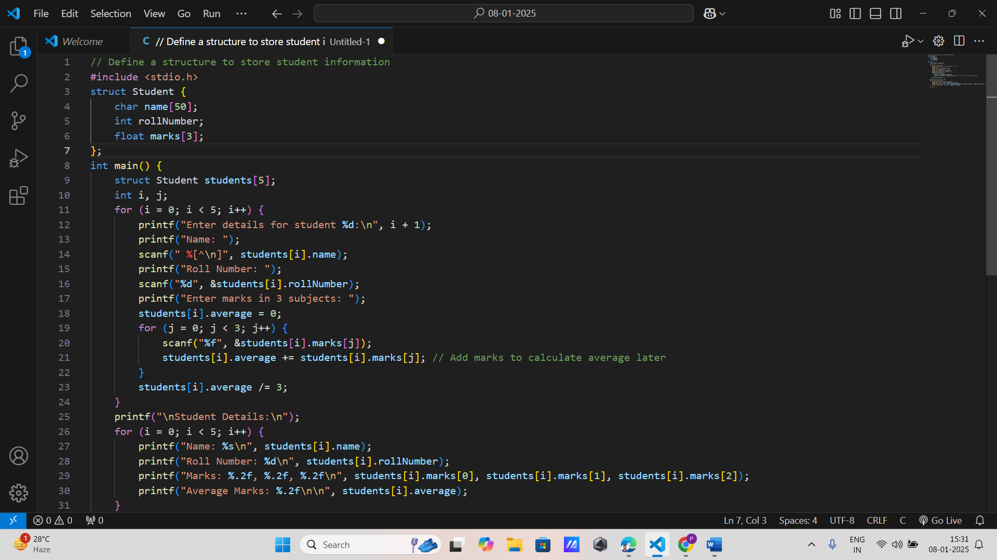

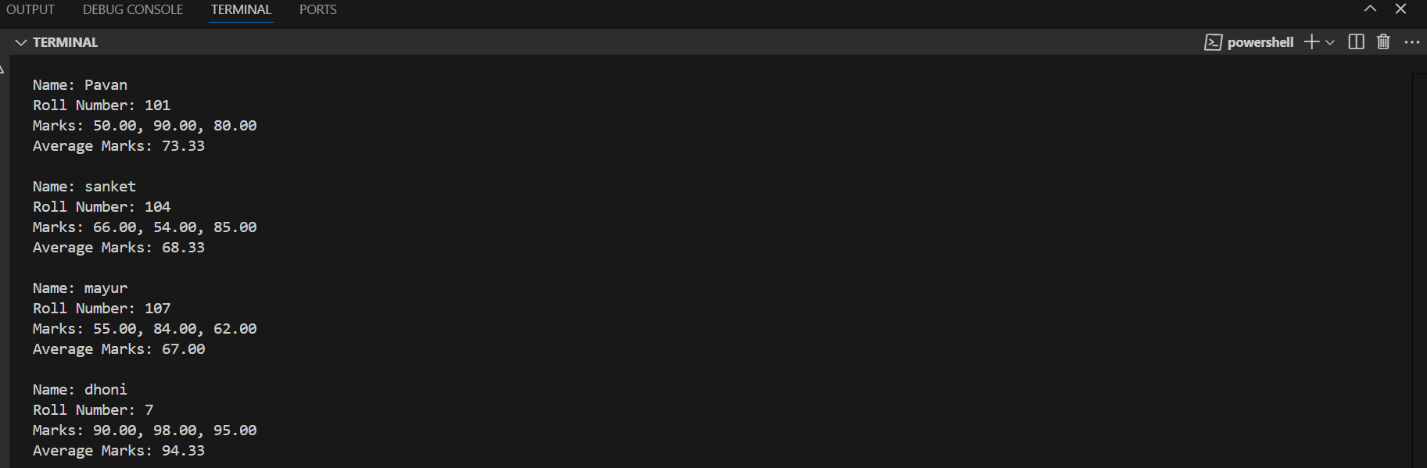

1. **Employee Details**:
   * Create a structure to store employee details like name, ID, salary, and department.
   * Write a function to display the details of employees whose salary is above a certain threshold.

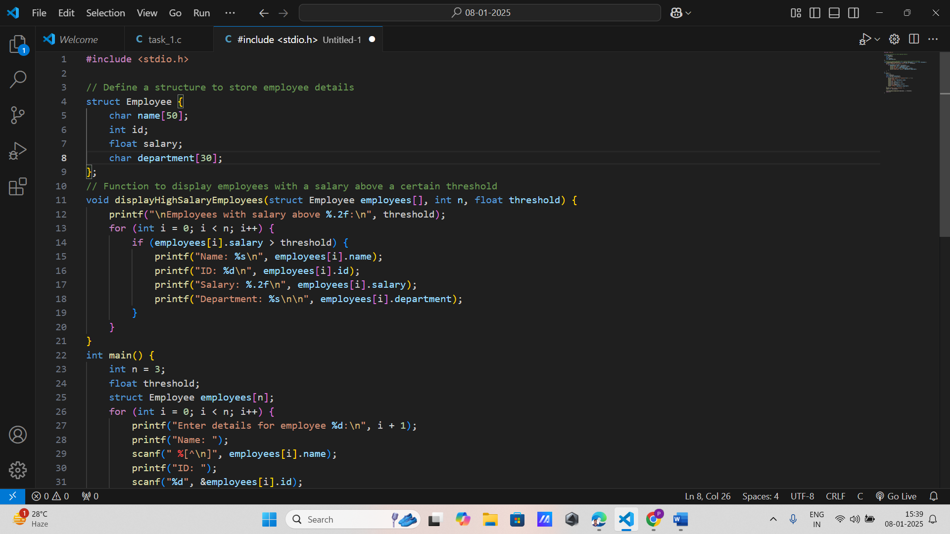

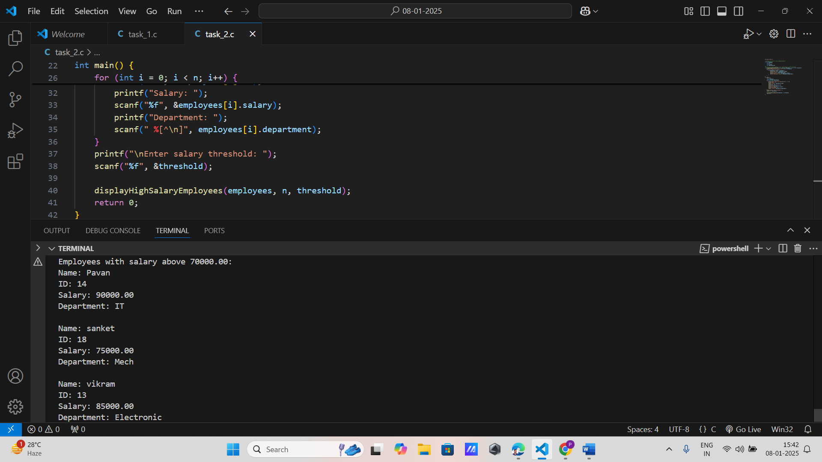

1. **Book Store Inventory**:
   * Define a structure to represent a book with fields for title, author, ISBN, and price.
   * Write a program to manage an inventory of books and allow searching by title.

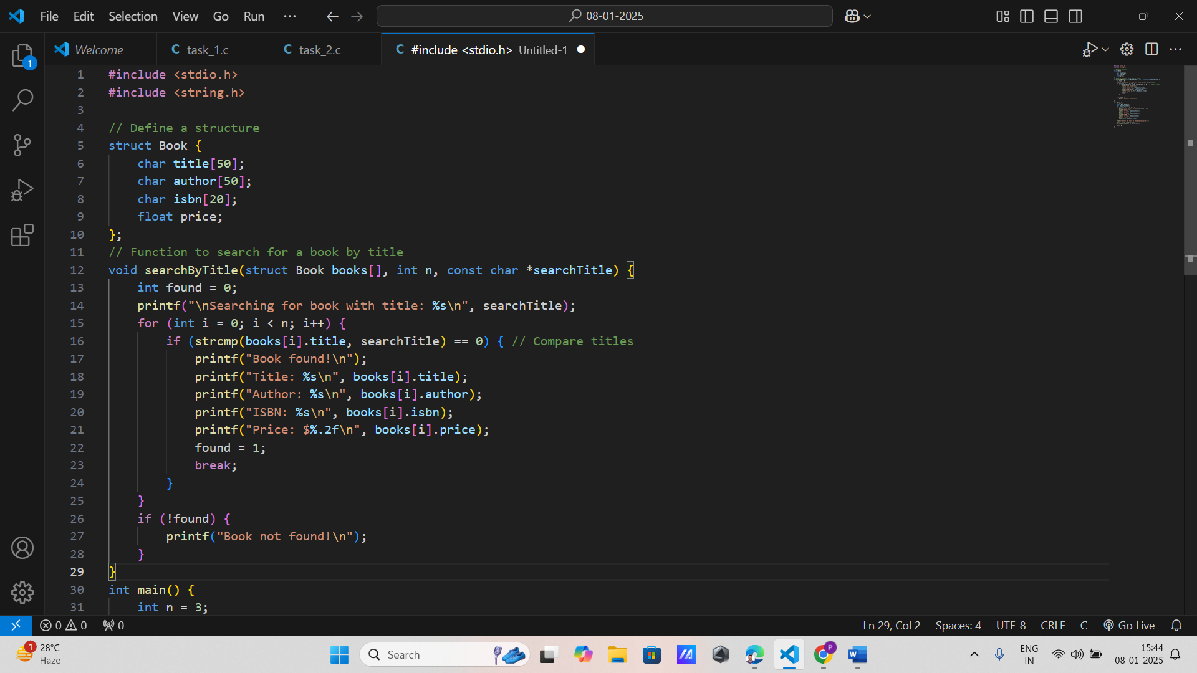

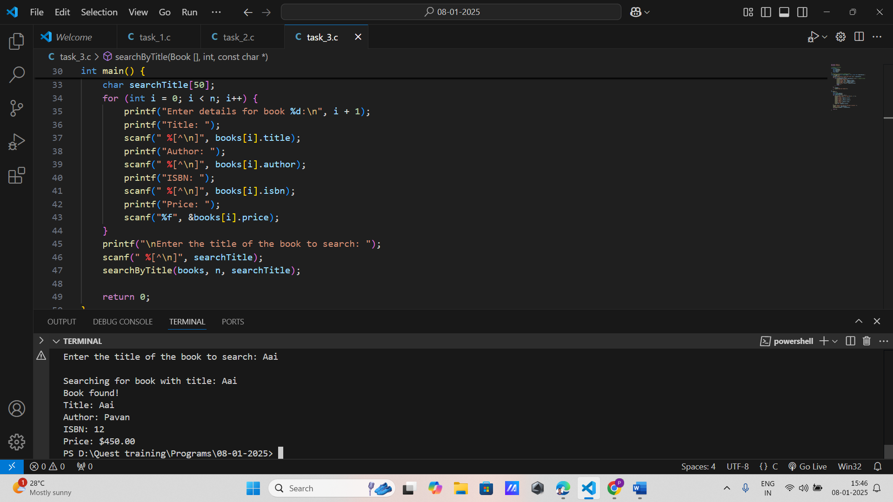

1. **Date Validation**:
   * Create a structure to represent a date with day, month, and year.
   * Write a function to validate if a given date is correct (consider leap years).

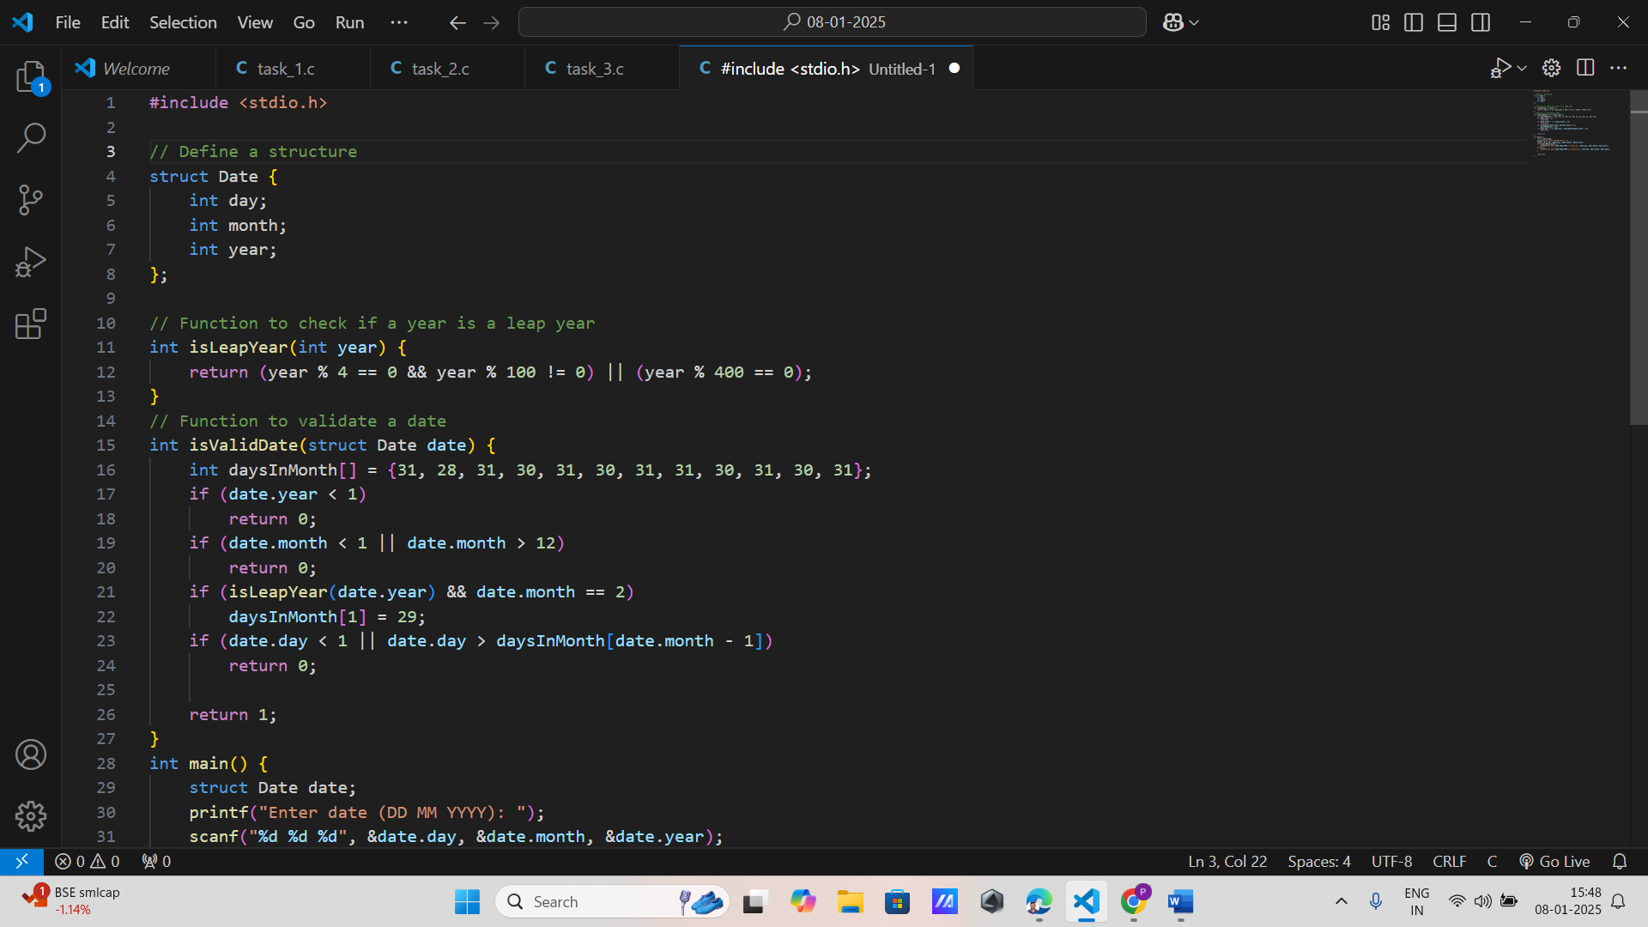

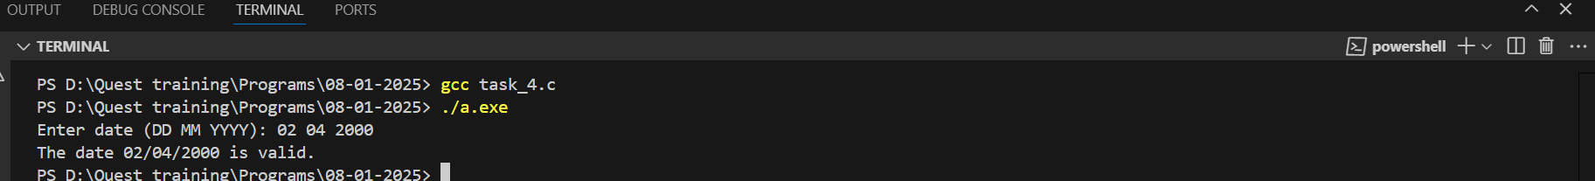

1. **Complex Numbers**:
   * Define a structure to represent a complex number with real and imaginary parts.
   * Implement functions to add, subtract, and multiply two complex numbers.

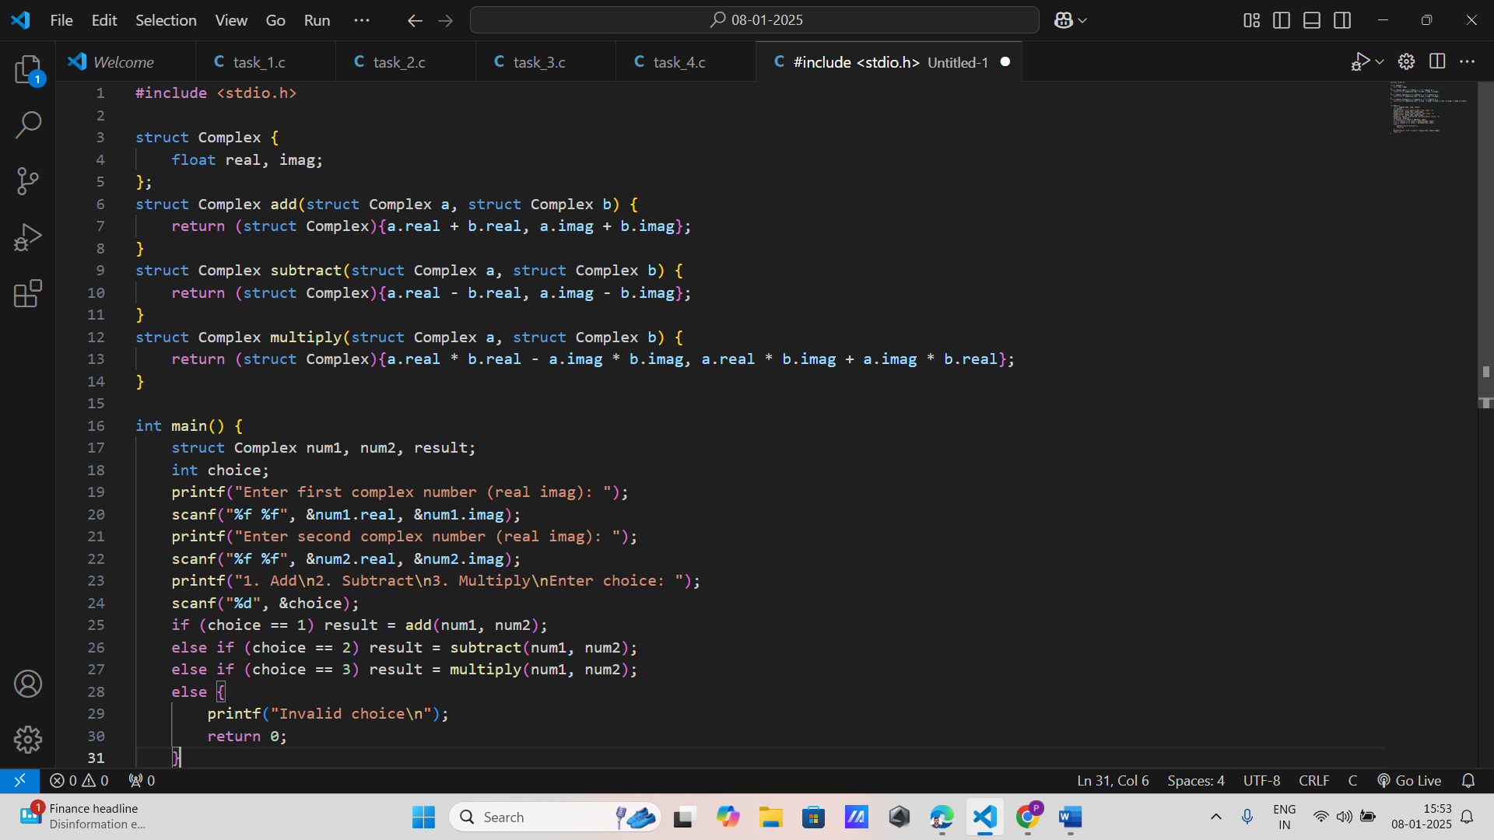

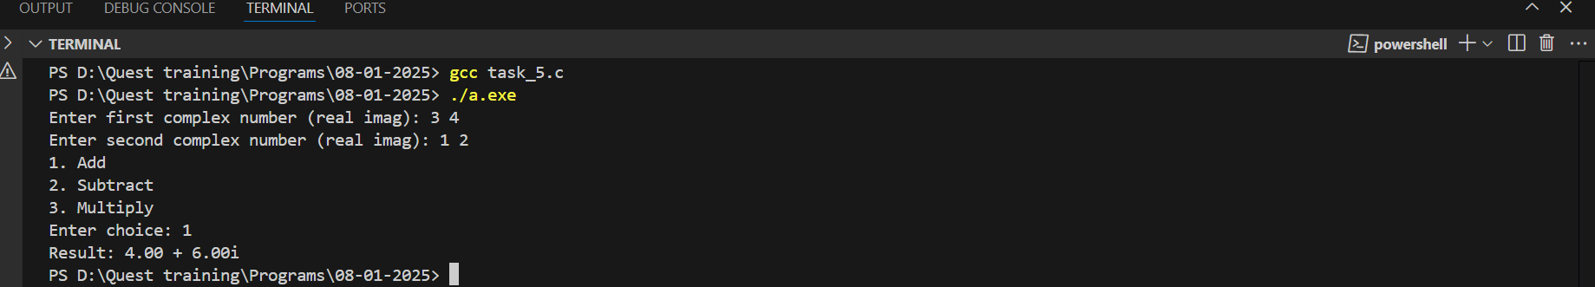

1. **Bank Account**:
   * Design a structure to store information about a bank account, including account number, account holder name, and balance.
   * Write a function to deposit and withdraw money, and display the updated balance.

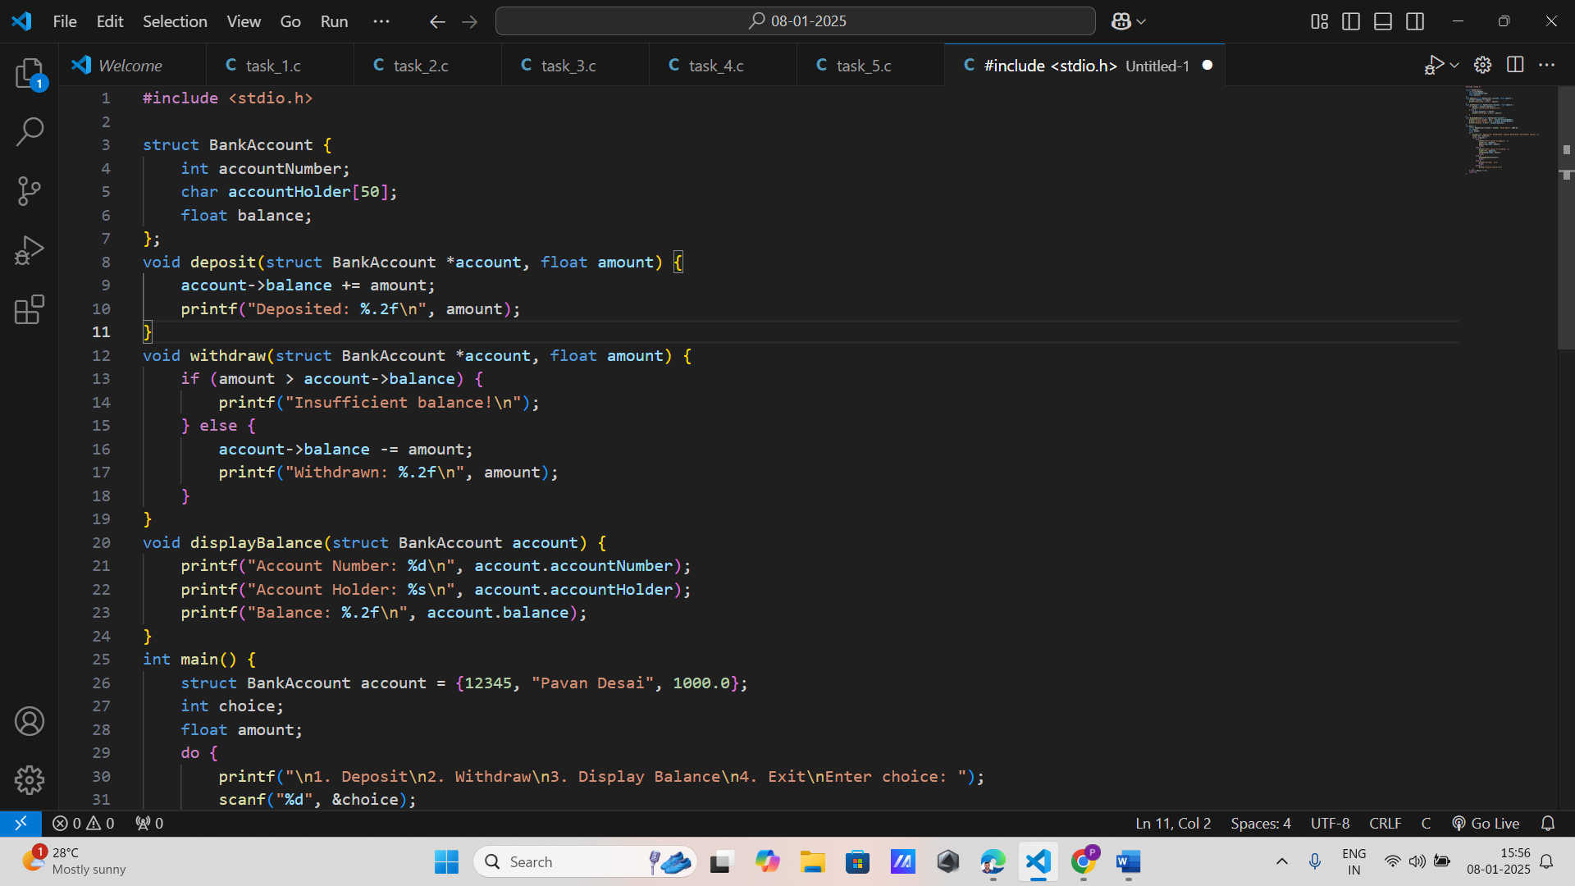

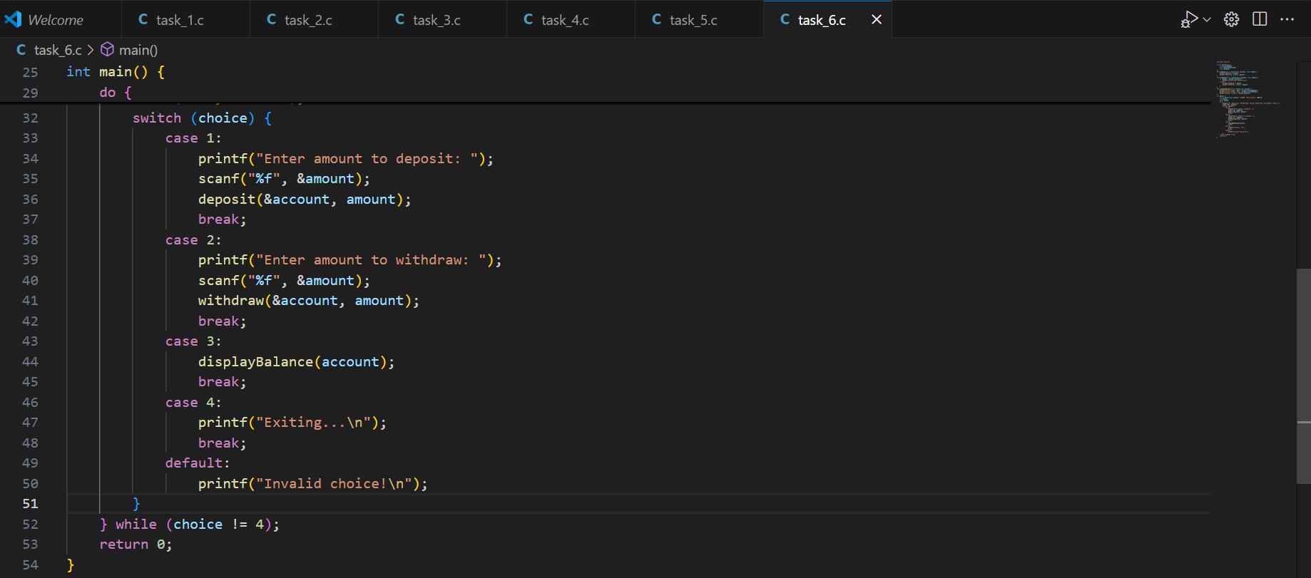

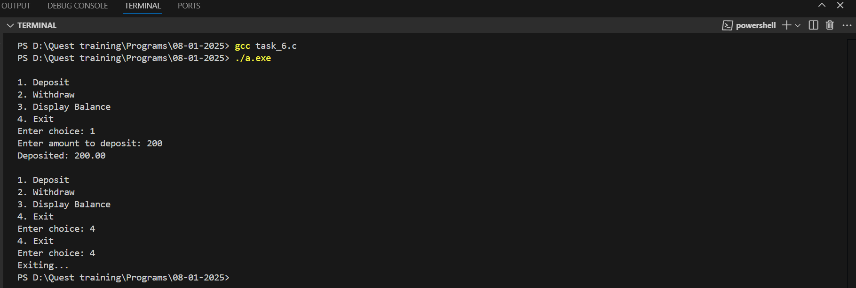

1. **Car Inventory System**:
   * Create a structure for a car with fields like make, model, year, and price.
   * Write a program to store details of multiple cars and print cars within a specified price range.

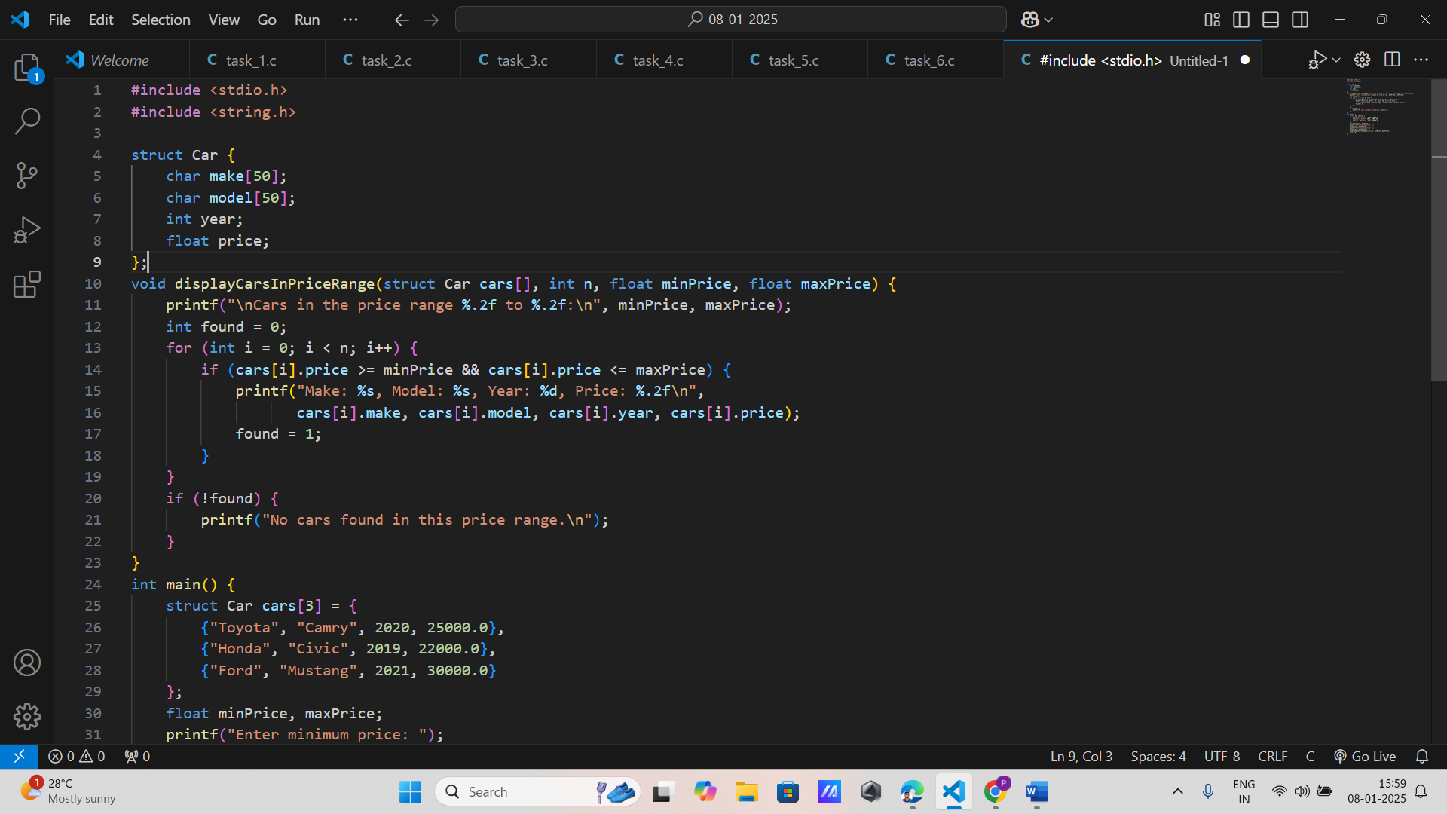

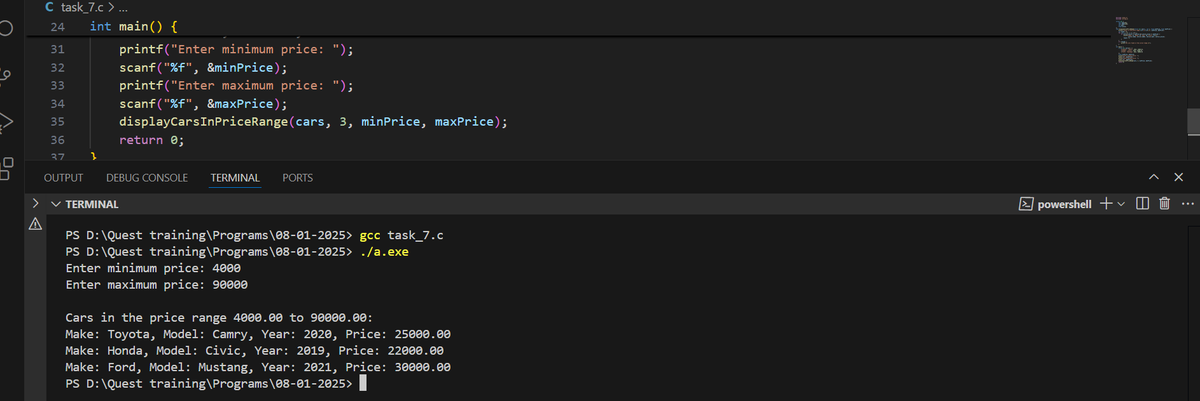

1. **Library Management**:
   * Define a structure for a library book with fields for title, author, publication year, and status (issued or available).
   * Write a function to issue and return books based on their status.

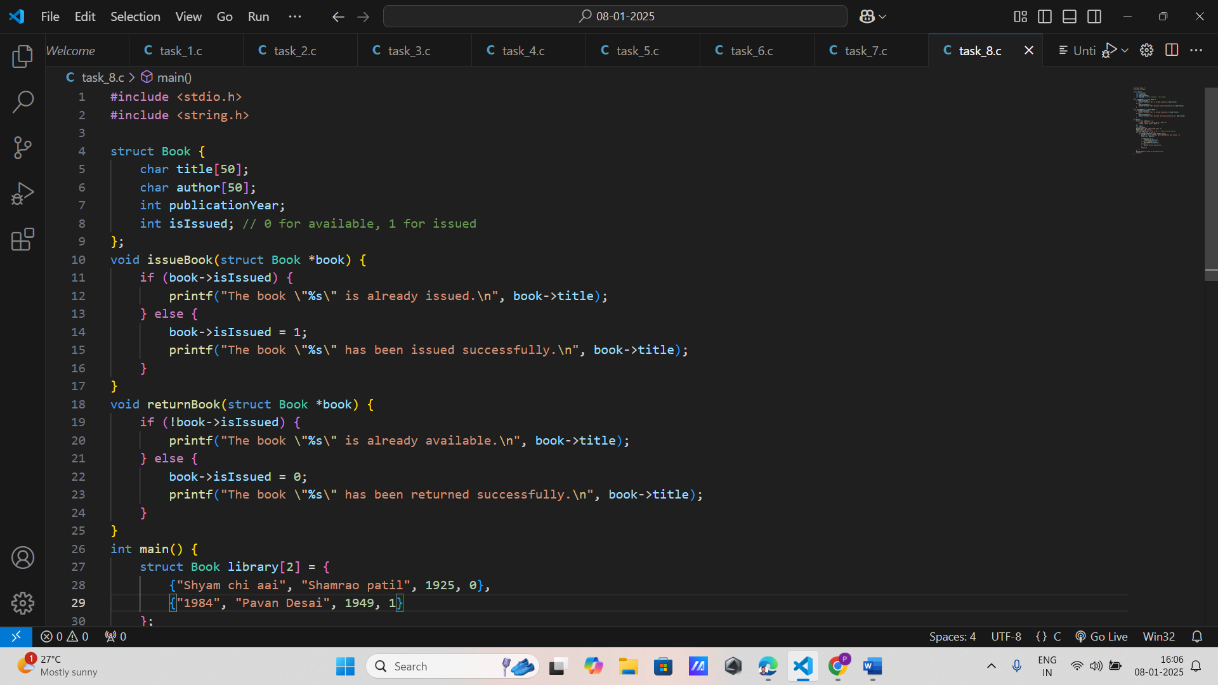

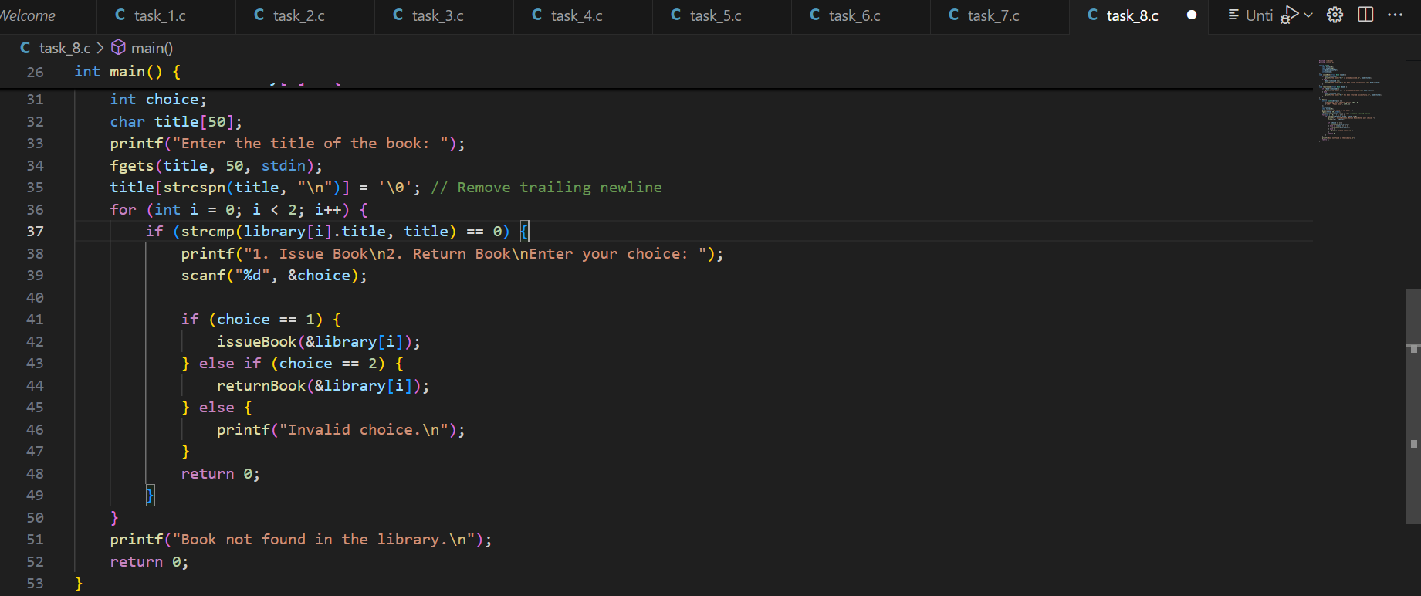

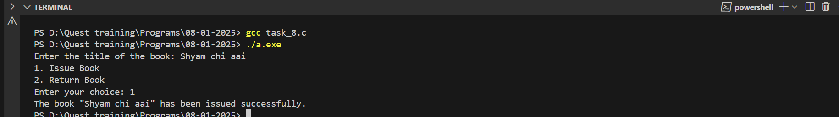

1. **Student Grades**:
   * Create a structure to store a student's name, roll number, and an array of grades.
   * Write a program to calculate and display the highest, lowest, and average grade for each student.

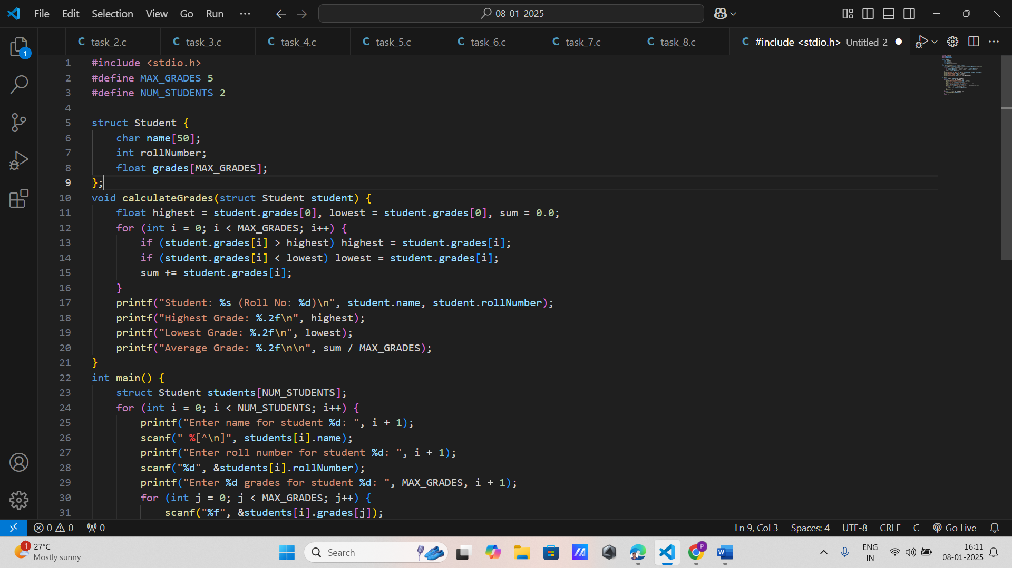

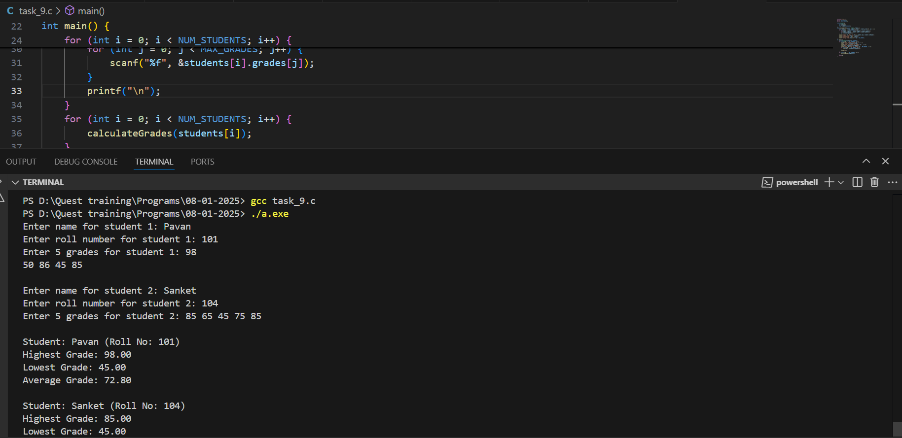

1. **Product Catalog**:
   * Define a structure to represent a product with fields for product ID, name, quantity, and price.
   * Write a program to update the quantity of products after a sale and calculate the total sales value.

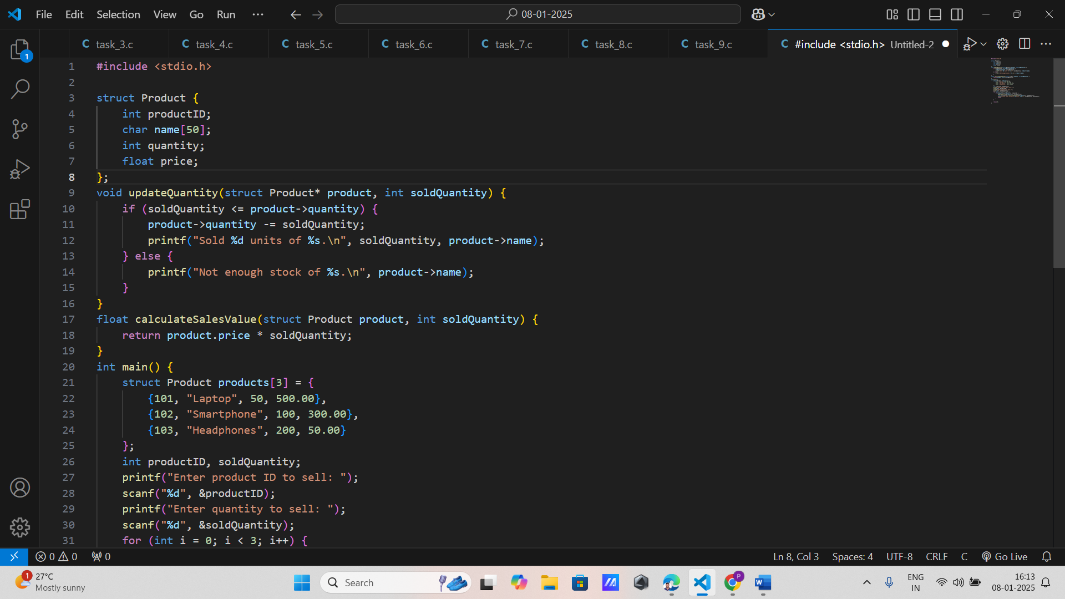

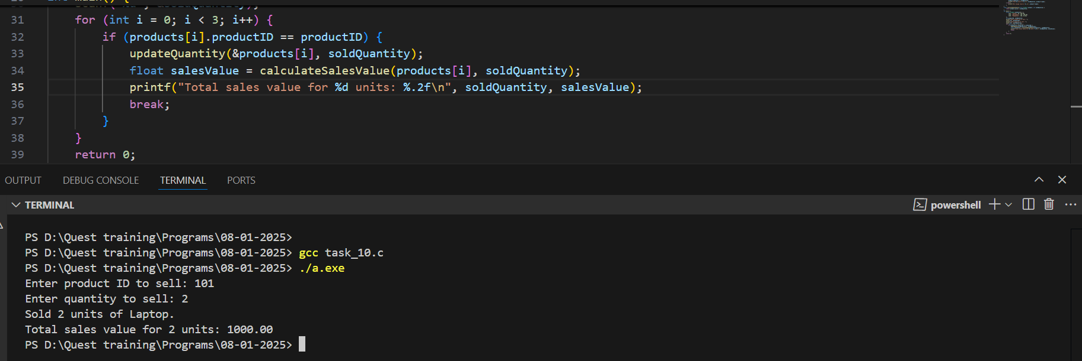

1. **Point Distance Calculation**:
   * Define a structure for a point in 2D space (x, y).
   * Write a function to calculate the distance between two points.

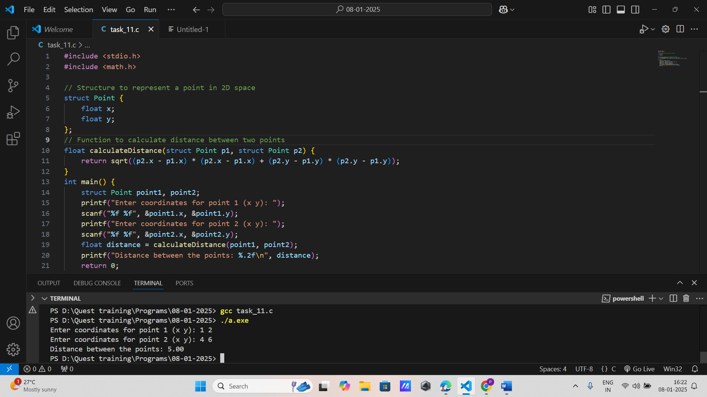

1. **Rectangle Properties**:
   * Create a structure for a rectangle with length and width.
   * Write functions to calculate the area and perimeter of the rectangle.

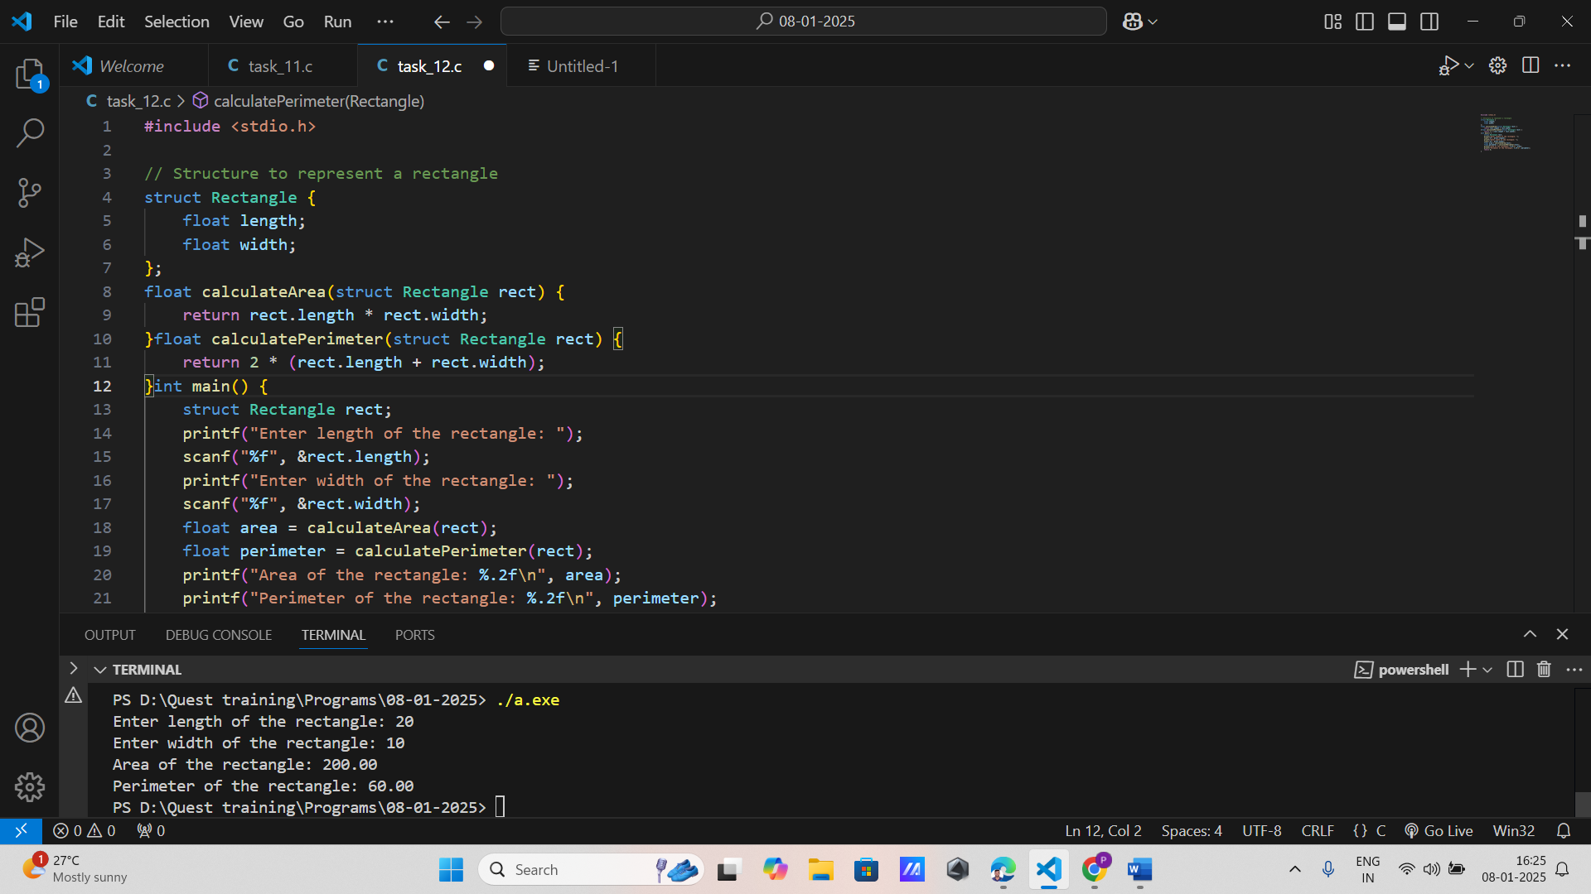

1. **Movie Details**:
   * Define a structure to store details of a movie, including title, director, release year, and rating.
   * Write a program to sort movies by their rating.

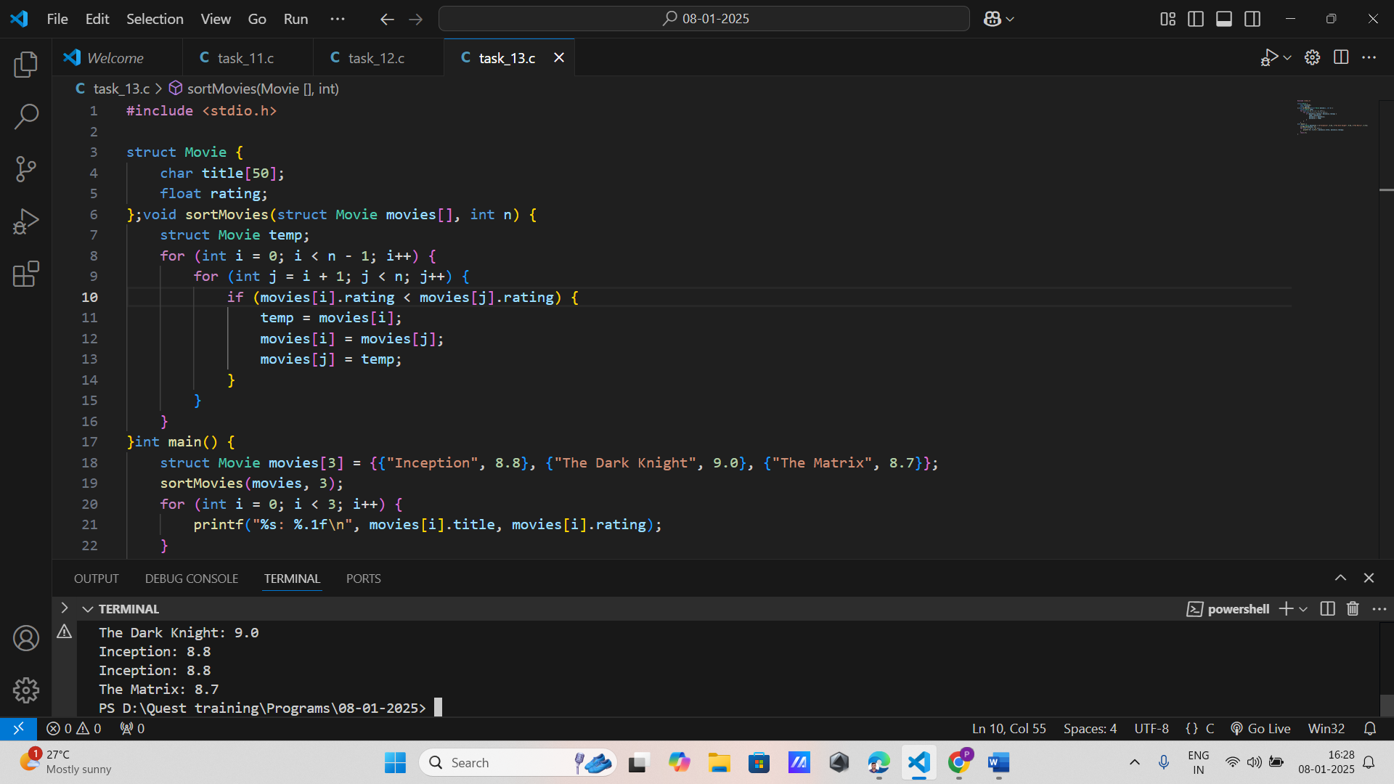

1. **Weather Report**:
   * Create a structure to store daily weather data, including date, temperature, and humidity.
   * Write a program to find the day with the highest temperature.

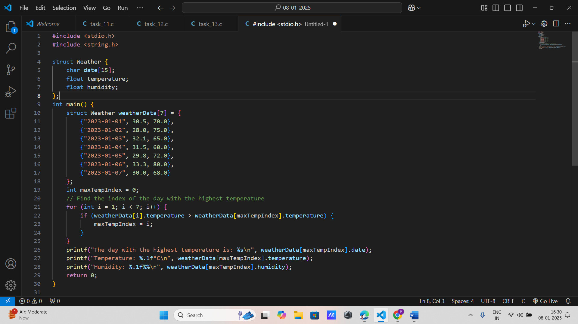

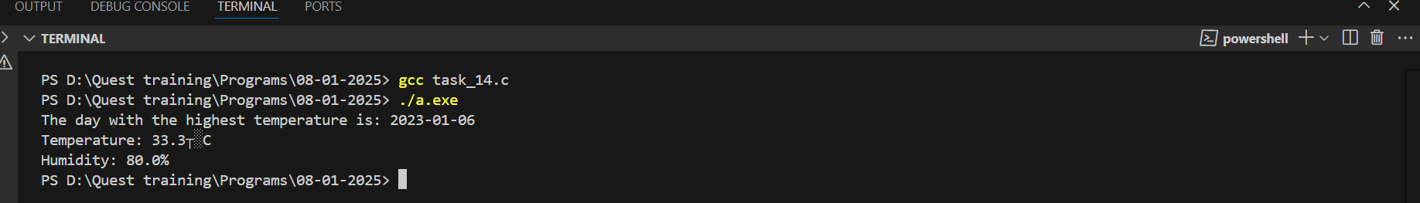

1. **Fraction Arithmetic**:
   * Define a structure for a fraction with numerator and denominator.
   * Write functions to add, subtract, multiply, and divide two fractions.

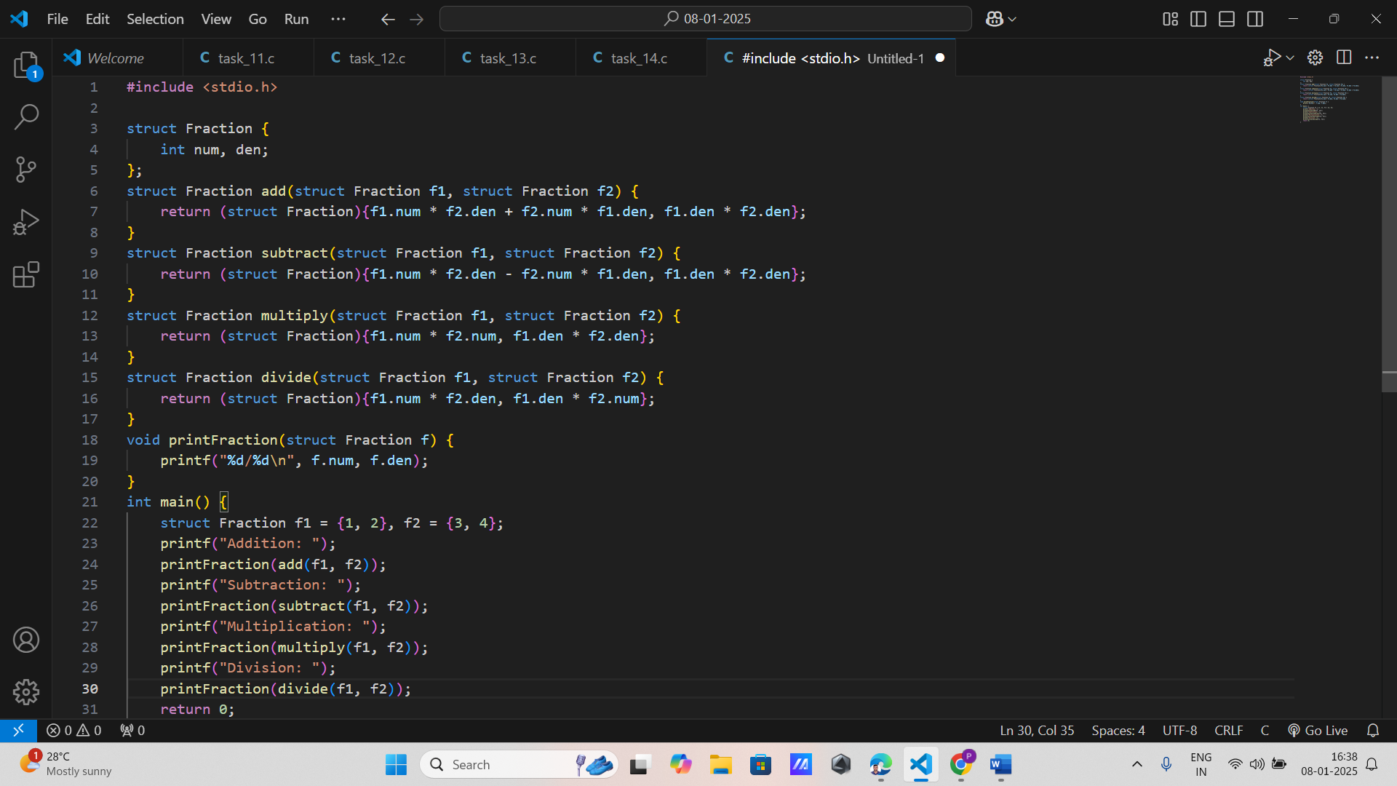

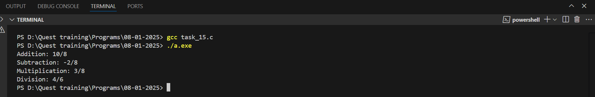

1. **Laptop Inventory**:
   * Create a structure to represent a laptop with fields for brand, model, processor, RAM, and price.
   * Write a program to list laptops within a specific price range.

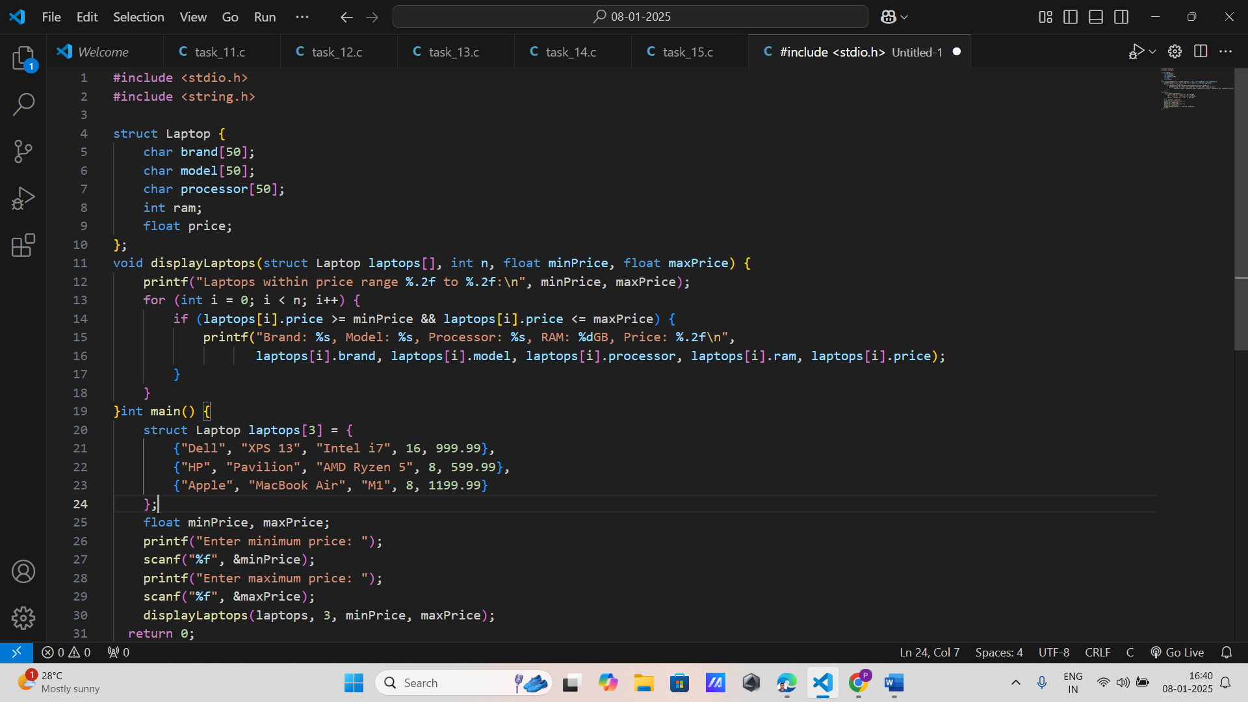



1. **Student Attendance**:
   * Define a structure to store attendance data, including student ID, total classes, and classes attended.
   * Write a program to calculate and display the attendance percentage for each student.

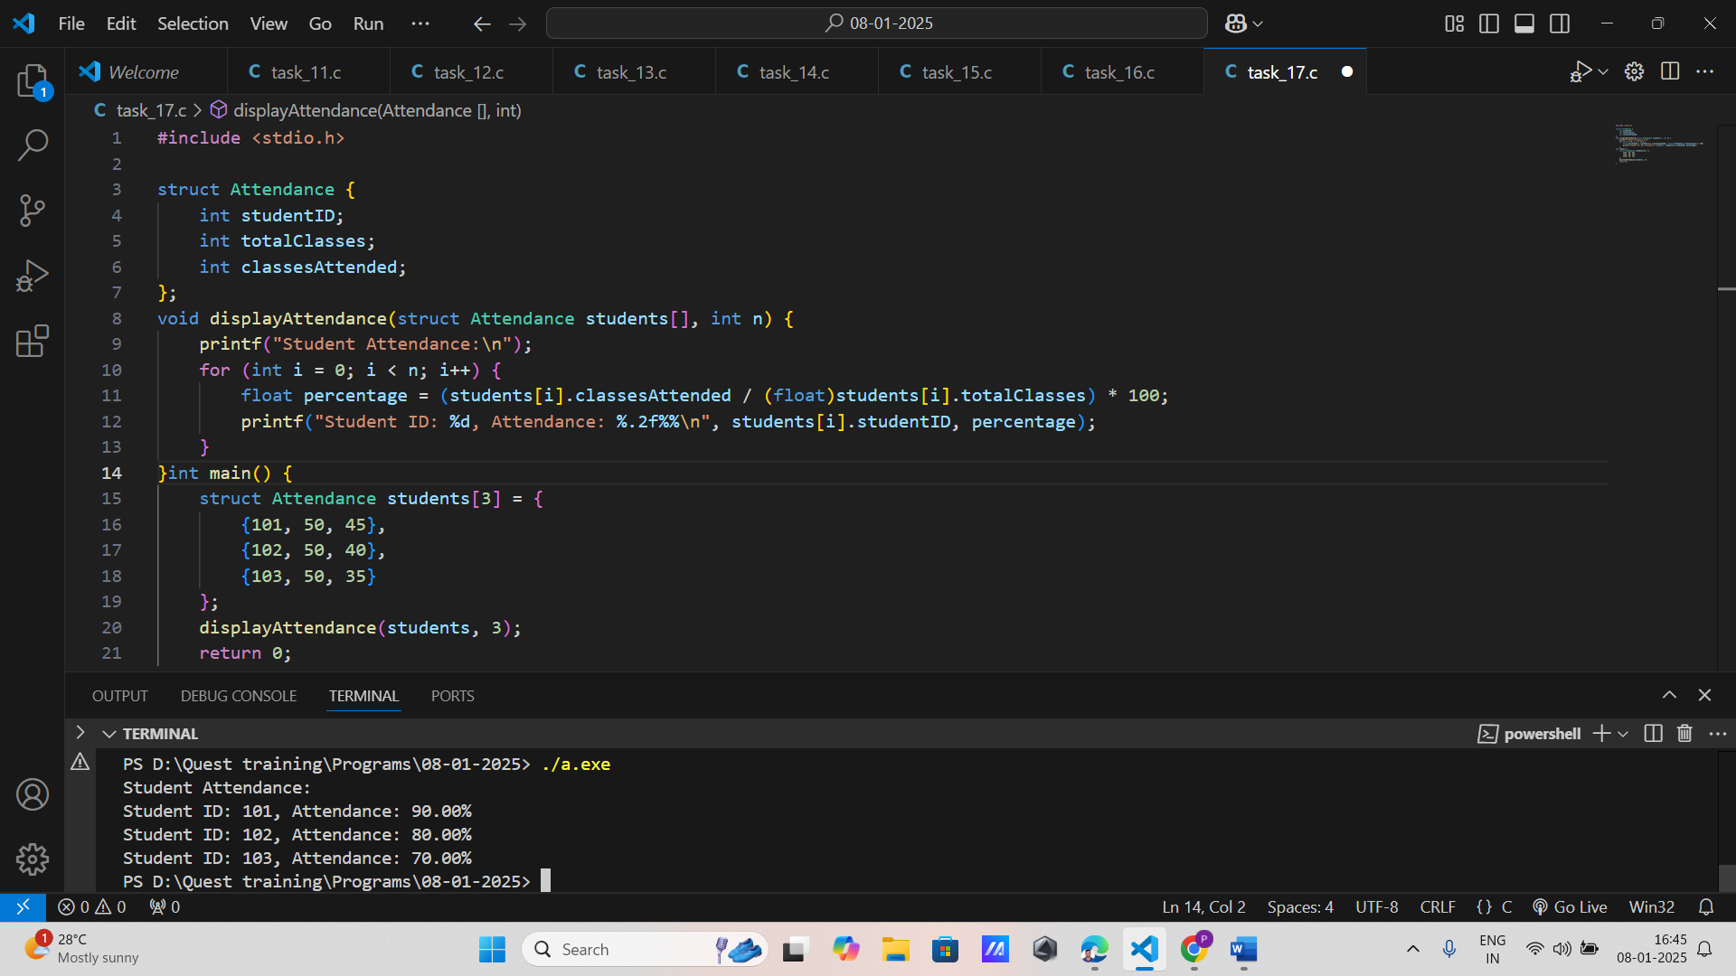

1. **Flight Information**:
   * Create a structure for a flight with fields for flight number, departure, destination, and duration.
   * Write a program to display flights that are less than a specified duration.

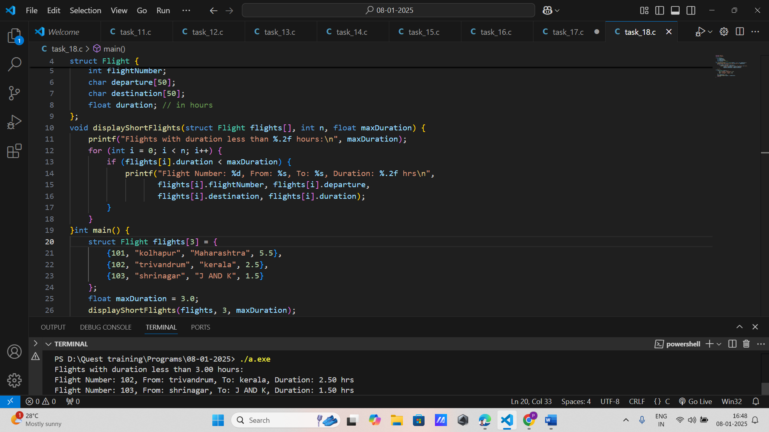

1. **Polynomial Representation**:
   * Define a structure to represent a term of a polynomial (coefficient and exponent).
   * Write functions to add and multiply two polynomials.

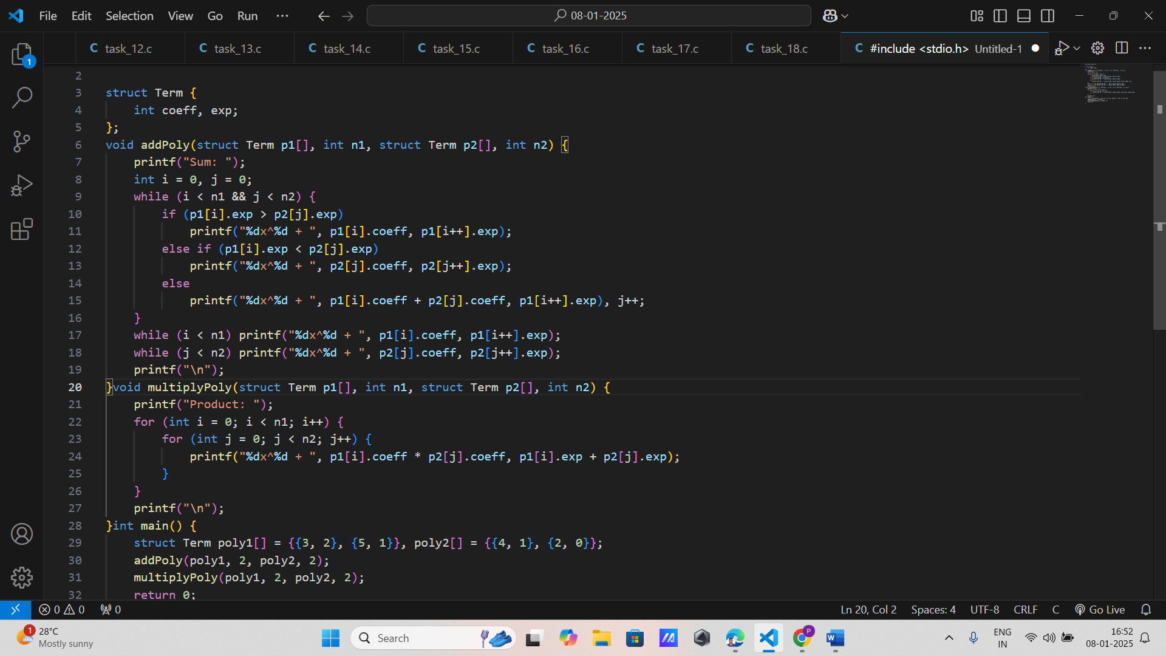

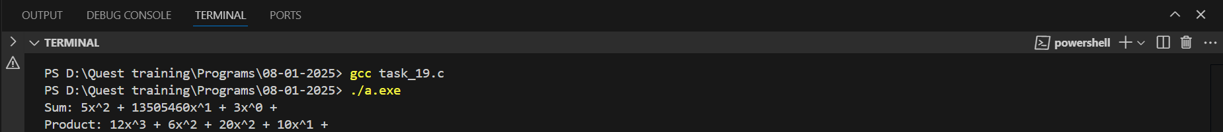

1. **Medical Records**:
   * Create a structure for a patient's medical record with fields for name, age, diagnosis, and treatment.
   * Write a program to search for patients by diagnosis.

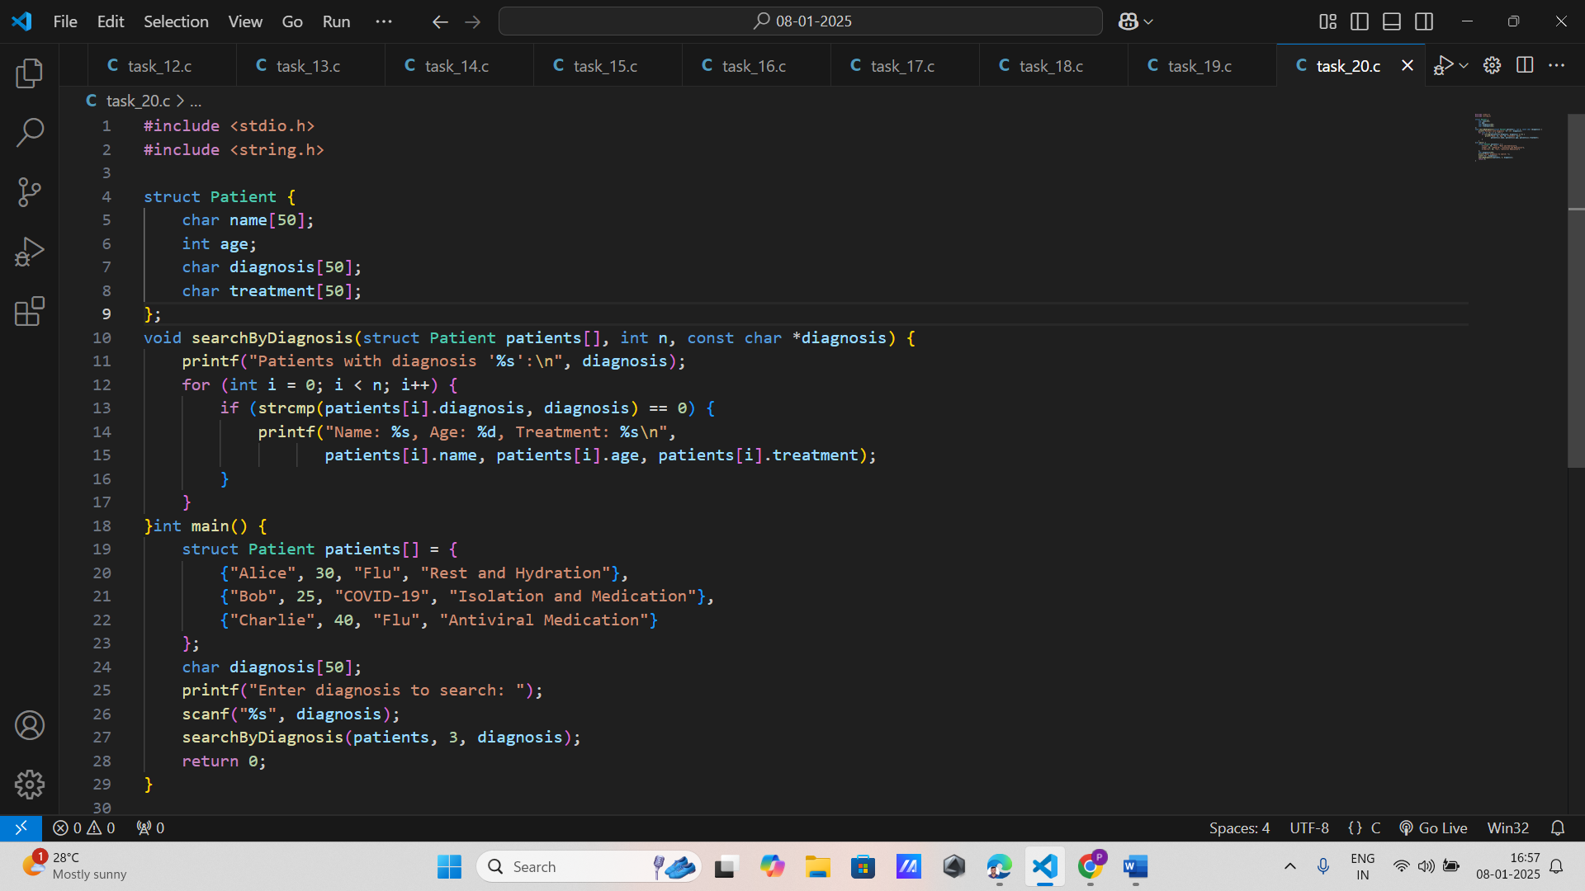

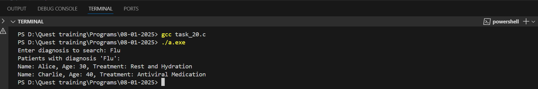

1. **Game Scores**:
   * Define a structure to store player information, including name, game played, and score.
   * Write a program to display the top scorer for each game.

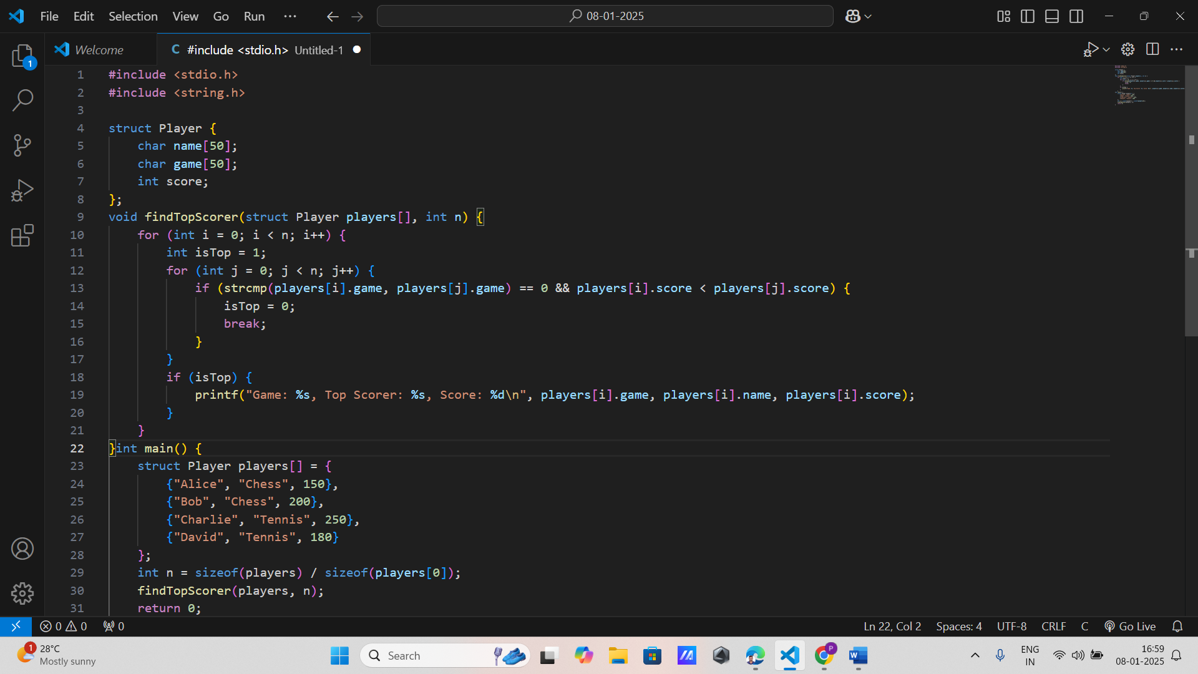

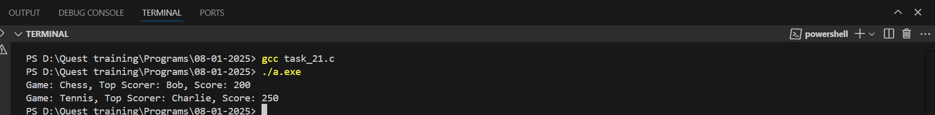

1. **City Information**:
   * Create a structure to store information about a city, including name, population, and area.
   * Write a program to calculate and display the population density of each city.

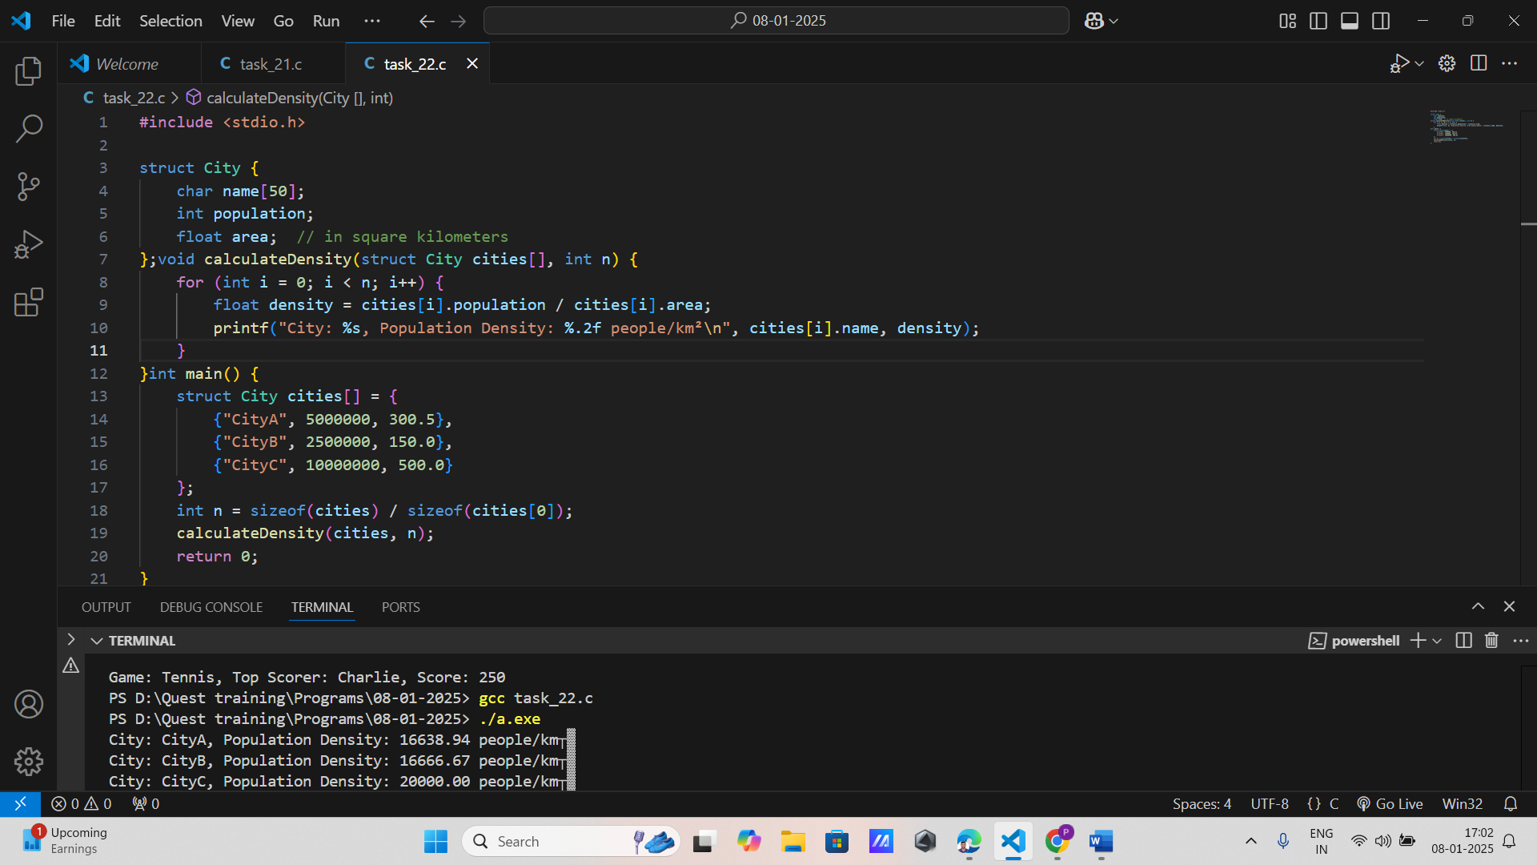

1. **Vehicle Registration**:
   * Define a structure for vehicle registration details, including registration number, owner, make, and year.
   * Write a program to list all vehicles registered in a given year.

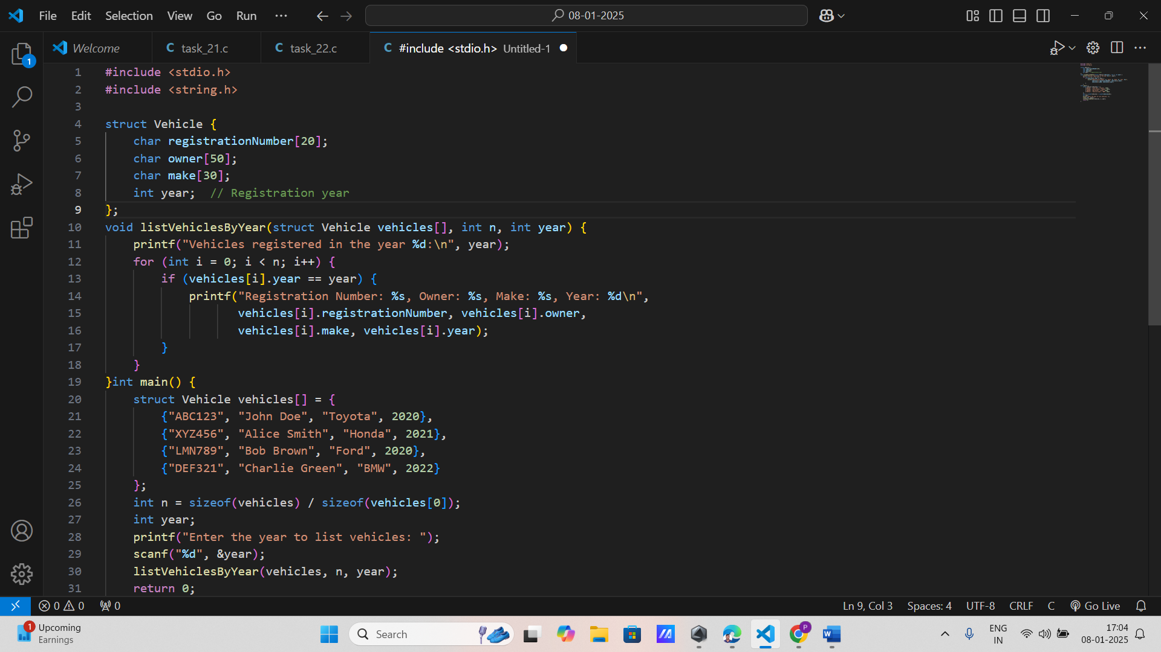

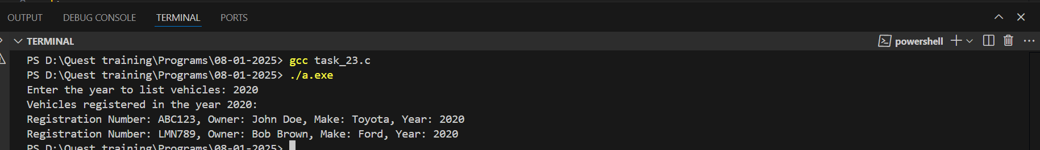

1. **Restaurant Menu**:
   * Create a structure to represent a menu item with fields for name, category, and price.
   * Write a program to display menu items in a specific category.

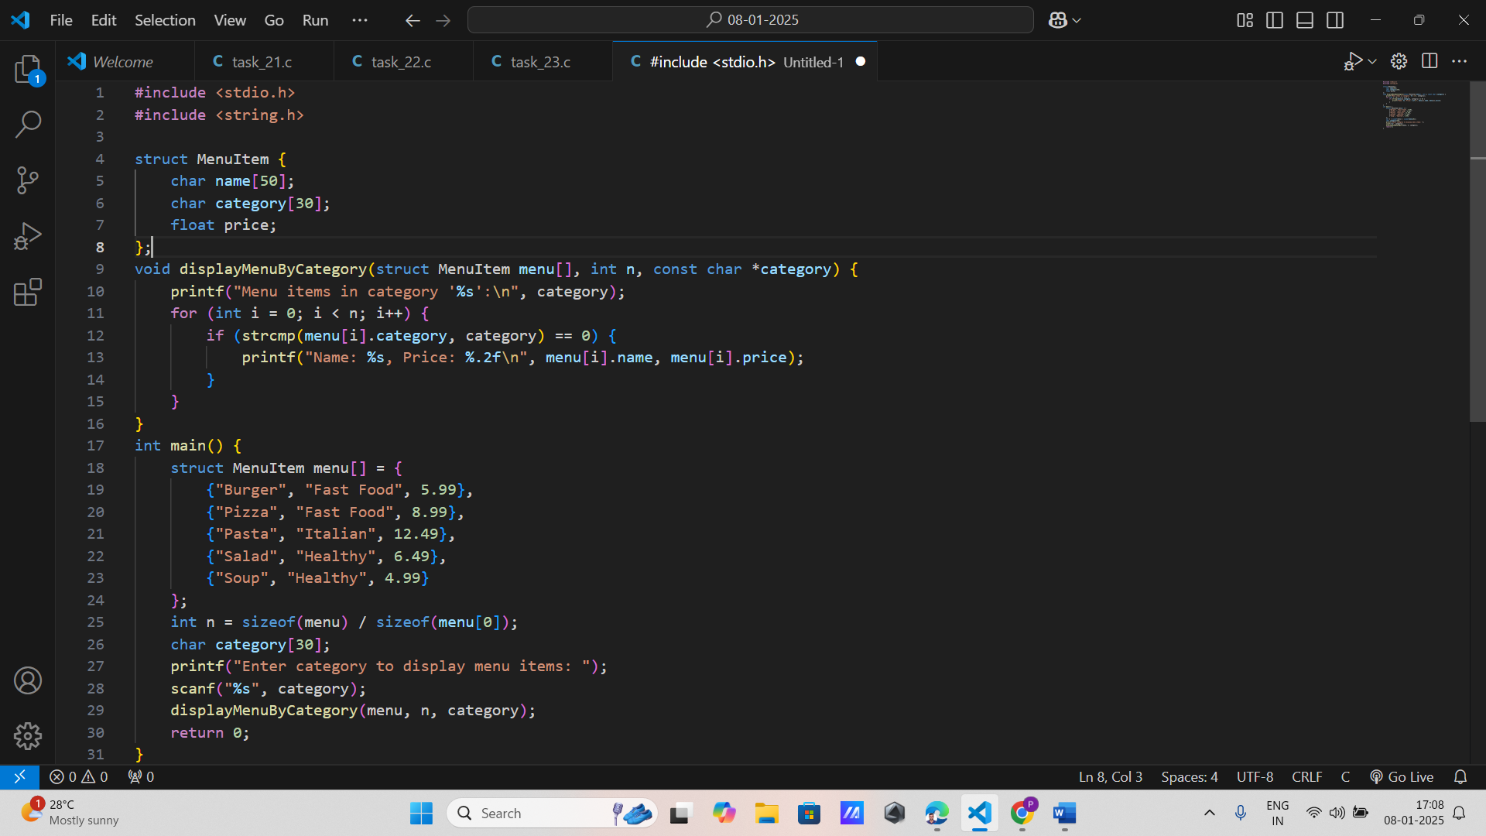

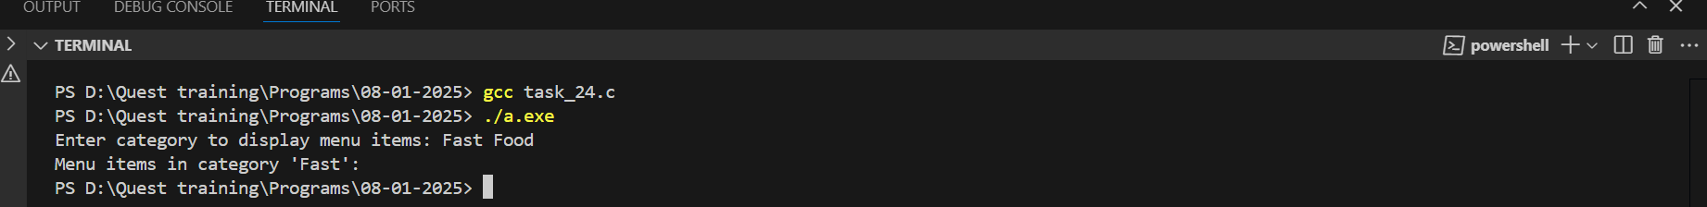

1. **Sports Team**:
   * Define a structure for a sports team with fields for team name, sport, number of players, and coach.
   * Write a program to display all teams playing a specific sport.

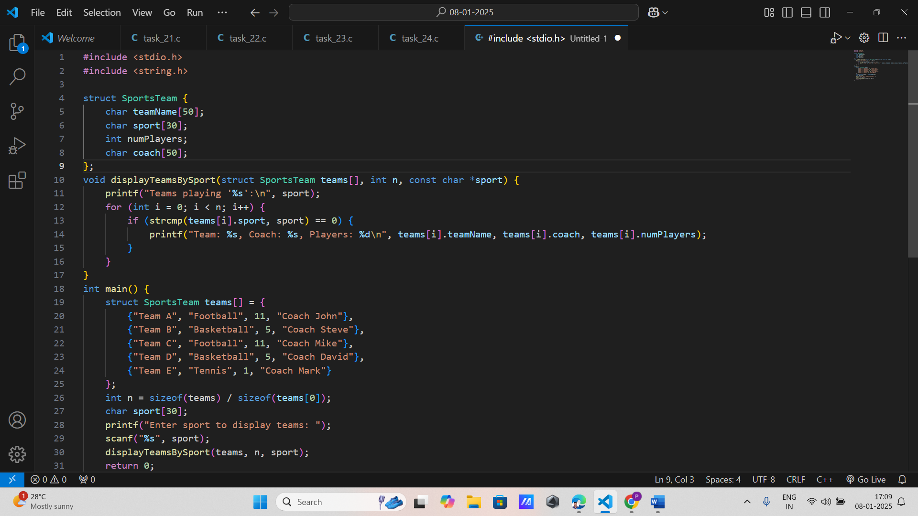

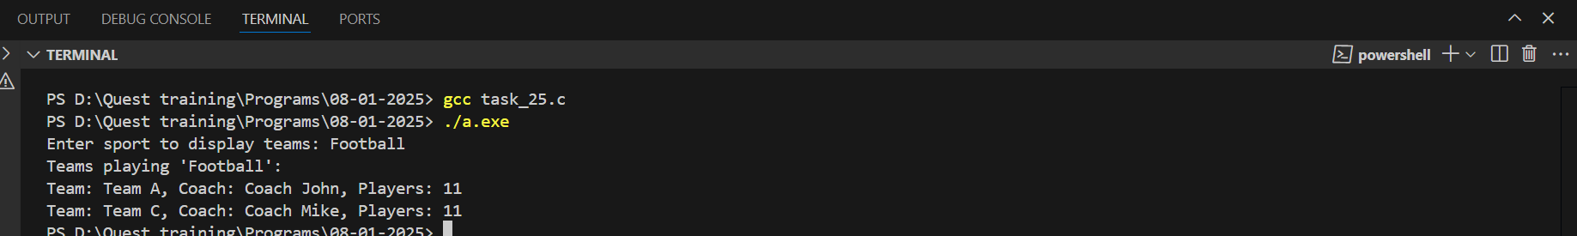

1. **Student Marks Analysis**:
   * Create a structure to store student marks in different subjects.
   * Write a program to calculate the total and percentage of marks for each student.

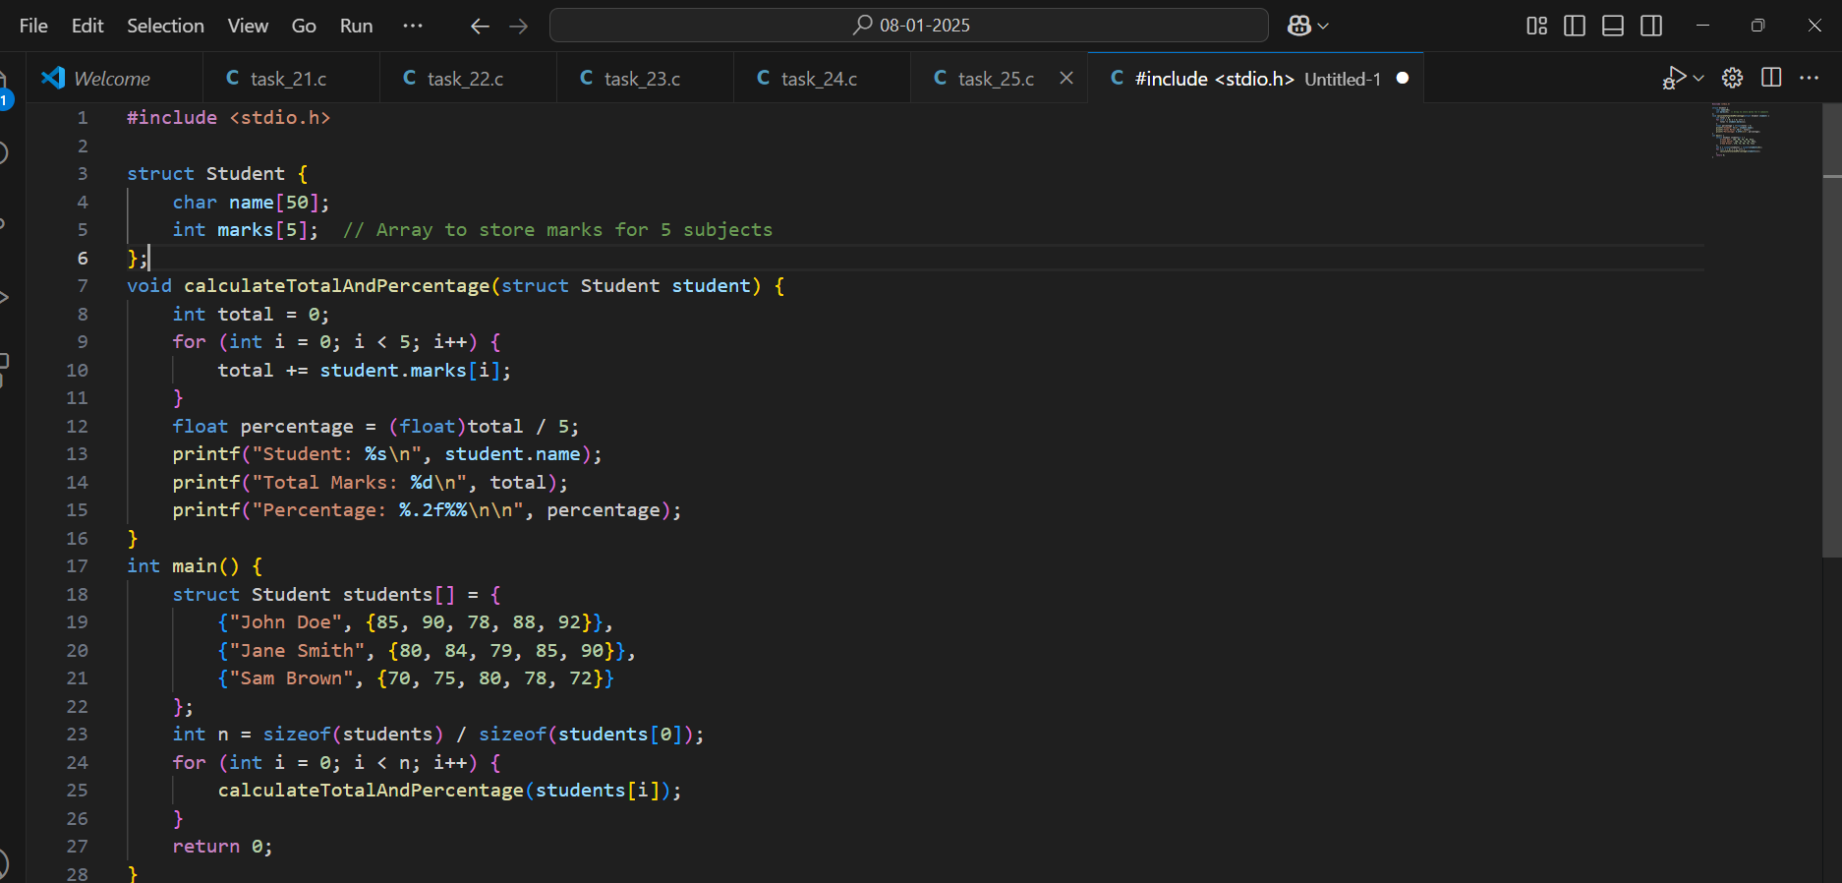

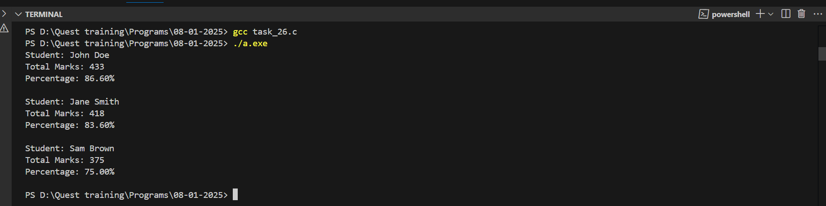

1. **E-commerce Product**:
   * Define a structure for an e-commerce product with fields for product ID, name, category, price, and stock.
   * Write a program to update the stock and calculate the total value of products in stock.

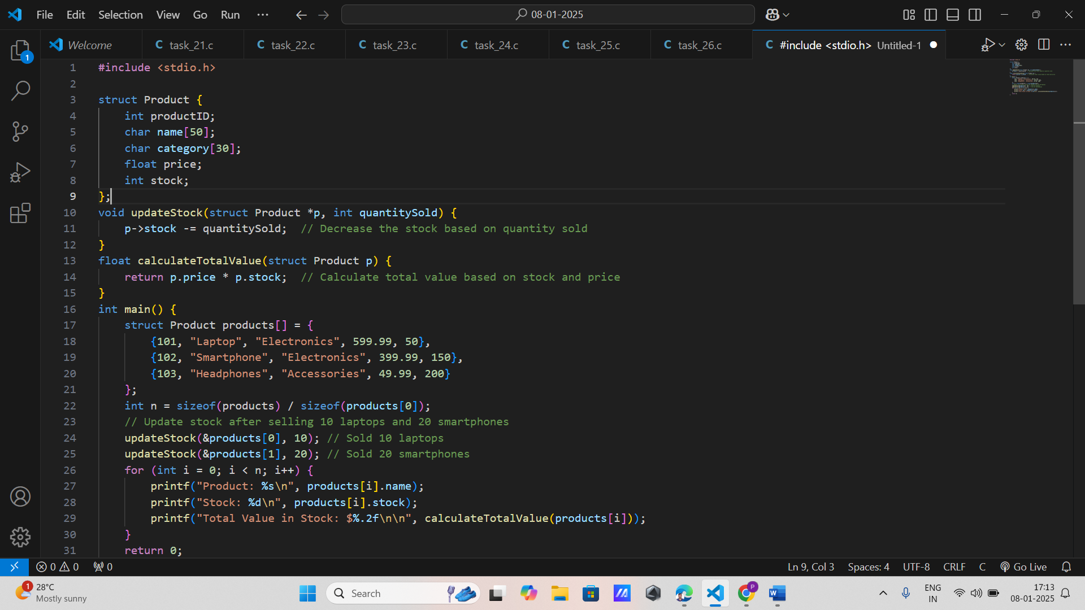

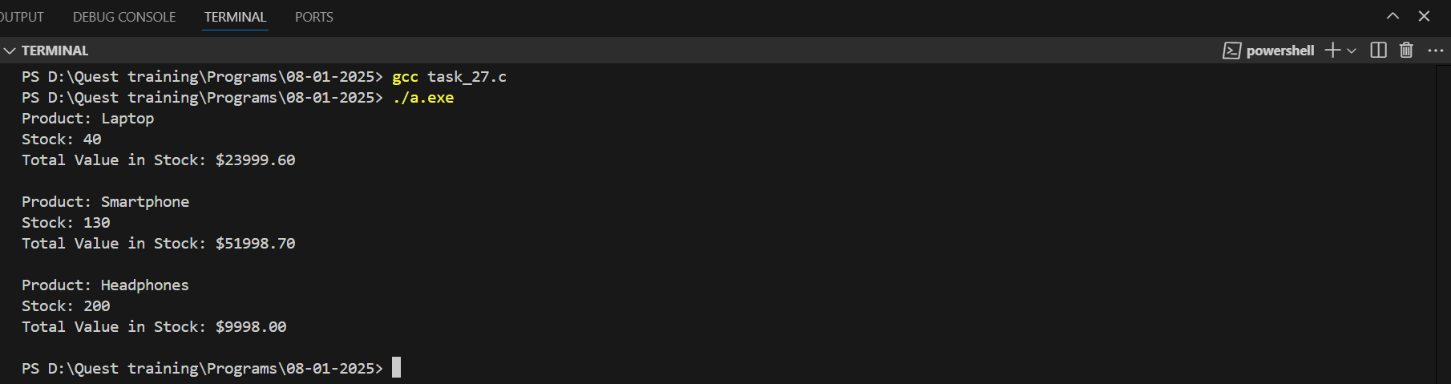

1. **Music Album**:
   * Create a structure to store details of a music album, including album name, artist, genre, and release year.
   * Write a program to display albums of a specific genre.

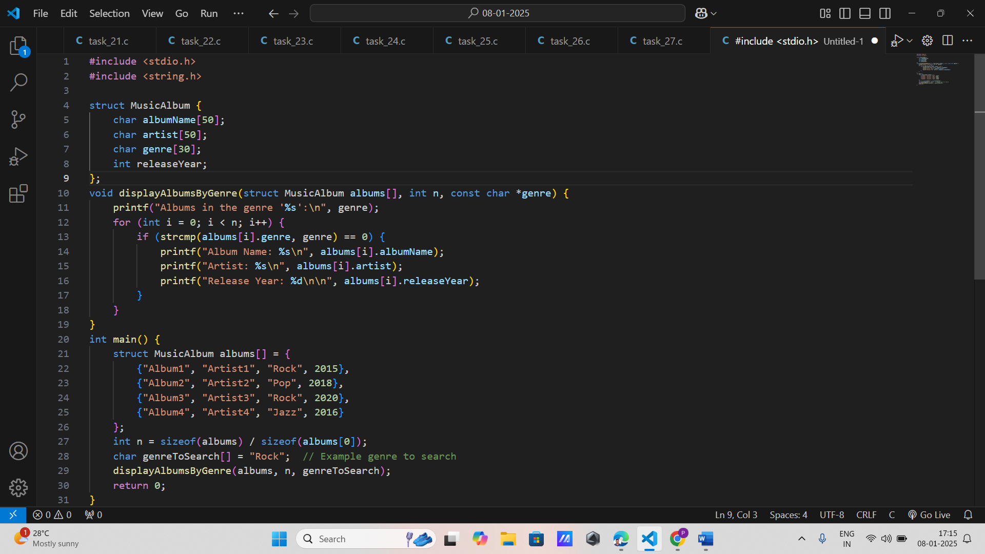

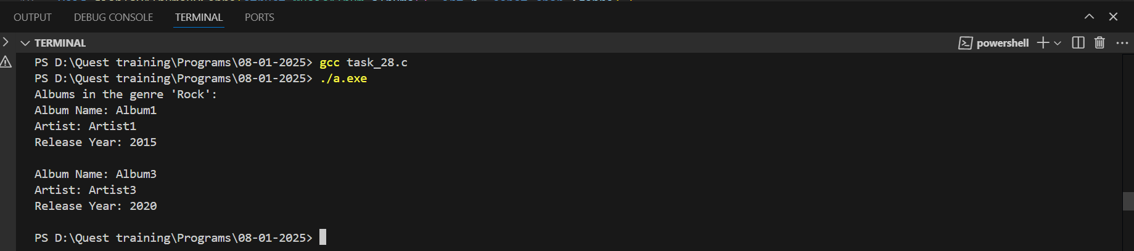

1. **Cinema Ticket Booking**:
   * Define a structure for a cinema ticket with fields for movie name, seat number, and price.
   * Write a program to book tickets and display the total revenue generated.

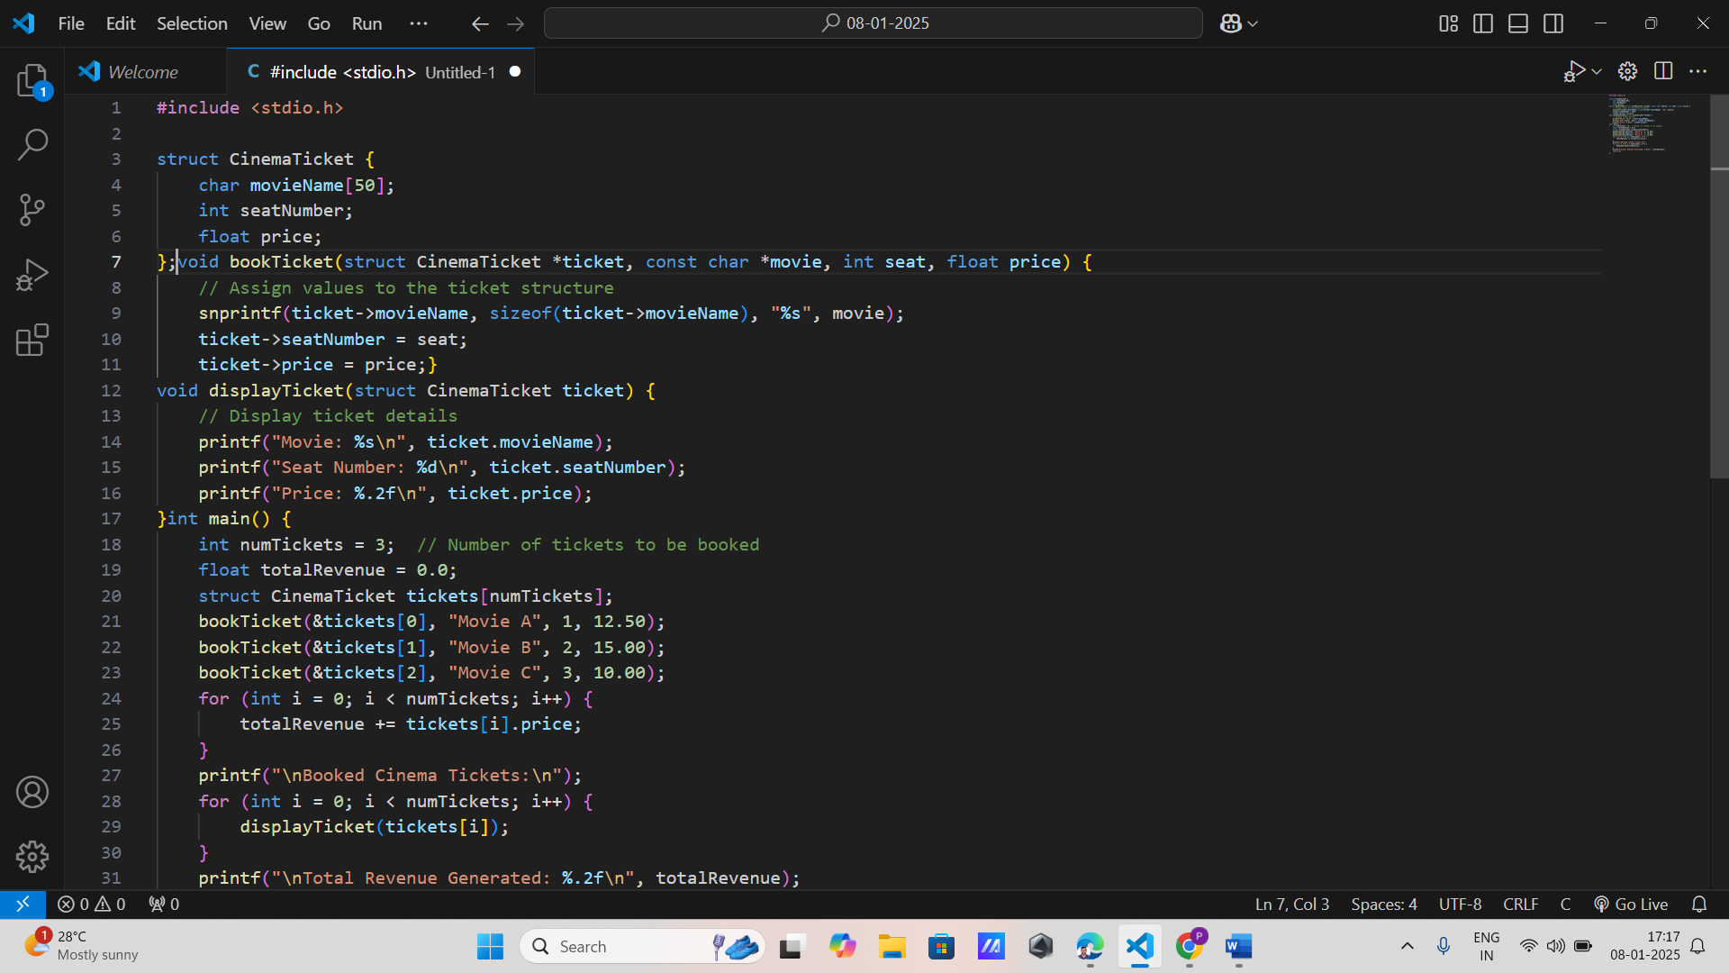

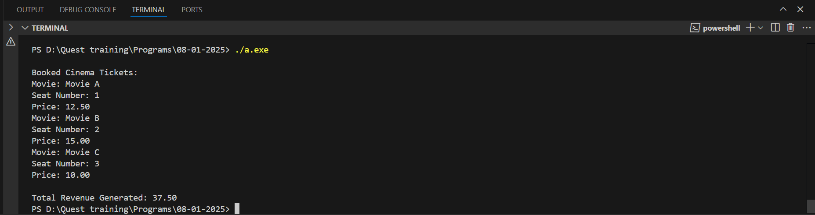

**20. University Courses:**

* Create a structure to store course details, including course code, name, instructor, and credits.
* Write a program to list all courses taught by a specific instructor.

